

ISS Pattern Recognition System Practice Module
Master of Technology in Artificial Intelligent System

AI-Based Pattern Recognition for Automated Vehicle Damage Assessment and Claims Data Structuring
Aug-Oct 2026

Group Name: ACERY (Group 34)
Team Members
Divakaran Pillai Arunkumar (A0337242J)
Miguel Rodel Felipe (A0336391B)
Lau Lay Khoon (A0249067W)
Lim Chong Jen (A0337414H)
Sun Yan (A0340238L)

Abstract

Keywords:

Contents
1. Introduction 8
1.1 Background 8
1.2 Project Objectives 11
2. System architecture and modelling (Rodel) 12
2.1 Purpose and design principles 12
2.2 High-level architecture 12
2.3 Modules and models 13
2.4 Technical design and deployment 14
2.5 Processing flow for one claim 15
2.6 Decision rules and human review 17
2.7 Data, storage and versioning 18
2.8 Model development lifecycle 19
2.9 Scope of the architecture 19
3. Module 1 (M1): Vehicle Part Segmentation 20
3.1 Executive Summary 20
3.2 Key Findings 21
3.3 Dataset and Vehicle Part Taxonomy 22
3.3.1 Dataset provenance and preparation 22
3.3.2 Vehicle part taxonomy 22
3.4 Experimental Stream 23
3.4.1 Experimental design 23
3.4.2 Loss function optimisation 24
3.4.3 Data augmentation 27
3.4.4 Model capacity scaling 27
3.4.5 Multi-architecture benchmarking 28
3.4.6 Overall experimental results 29
3.4.7 Per-panel segmentation performance 30
3.4.8 Qualitative inspection 31
3.5 Discussion 34
3.5.1 Compound loss improved segmentation of underrepresented vehicle parts 34
3.5.2 Increasing model capacity improved SegFormer performance 34
3.5.3 YOLOv8m-seg was strongest for vehicle part segmentation 35
3.5.4 Segmentation performance varied across vehicle parts 35
3.5.5 Implications for M1–M2 integration 36
3.6 Limitations and implementation considerations 37
3.7 Conclusion 38
4.0 Module 2 (M2: Vehicle Damage Identification and Segmentation) 39
4.1 Executive Summary 40
4.2 Key findings 41
4.3 Dataset and Damage Taxonomy 42
4.4 Experimental Stream A: Image-Level Multi-Label Damage Classification 43
4.4.1 Rationale 43
4.4.2 Classification Loss and Class-Imbalance Handling 44
4.5 Classification Experimental Progression 46
4.5.1 ResNet50 Per-Class Classification Performance 48
4.6 Experimental Stream B: Pixel-Level Damage Segmentation 49
4.6.1 Per-Class Damage Segmentation Performance 50
4.7 Discussion: Classification Versus Segmentation Architecture Findings 51
4.7.1 ResNet50 was strongest for image-level damage classification 51
4.7.2 SegFormer-B3 was strongest when spatial localisation was required 51
4.7.3 Damage morphology may favour dense segmentation 52
4.7.4 Classification and segmentation results should not be directly ranked 53
4.7.5 Integration with M1 Vehicle-Part Segmentation 54
4.7.6 Damage-to-Part Assignment Performance 55
4.7.7 M2 Architectural Verdict 56
4.8. Overall Conclusion 57
5.0 Module 1 & Module 2 Comprehensive Benchmarking & Architectural Analysis 58
5.1 Executive Summary 59
5.2 Key Findings 59
5.3 Dataset and Damage Taxonomy 61
5.3.1 Dataset Sources 61
5.3.2 Data Splitting and Leakage Prevention 62
5.3.3 Vehicle Part and Damage Taxonomy 63
5.4 Experimental Stream 63
5.4.1 Overview of the Integration Pipeline 63
5.4.2 Deterministic Damage-to-Part Assignment 64
5.4.3 Cross-Architecture Integration Benchmark 66
5.4.4 Sensitivity Analysis: Minimum Damage Component Size 67
5.4.5 Analysis of Unresolved Damage Regions 68
5.4.6 Seam-Guided Component Splitting Experiment 72
5.5 Discussion 74
5.5.1 Feasibility of Integrating Independently Trained Segmentation Models 74
5.5.2 Selection of the Preferred Model Combination 74
5.5.3 Challenges of Damage Extending Across Multiple Vehicle Parts 75
5.6 Conclusion 76
6.0 Module 4 (M4): Page Reading (Rodel) 77
6.1 Role in the document branch 77
6.2 Pretrained OCR model 77
6.3 Processing workflow 78
6.4 Output and handoff to M5 and M6 79
6.5 Limitations 81
7.0 Module 5 (M5): Line-item Extraction (Arun) 81
7.1 Model 81
7.2 Training data 82
7.3 Aligning labels with OCR boxes 82
7.4 Extraction workflow 84
7.5 Training 85
7.6 Validation results 86
7.7 Limitations 87
8.0 Module 6 (M6): Pen-mark Recognition (Rodel) 88
8.1 Model 88
8.2 Training data and mark classes 89
8.3 Training 90
8.4 Detection results and score thresholds 91
8.5 Linking marks to repair rows 92
8.6 Human review and revisions 94
8.7 Integration and limitations 95
9.0 M7 (Edwin) 96
10. M8 (Edwin) 97
11. Integration of all modules (Rodel) 98
12.0 Overall discussion (everyone) 99
13.0 Limitations (everyone) 100
14.0 Conclusion 101
15.0 References 102

Table 1. Description of the ten selected vehicle parts and their associated segmentation challenges. 22
Table 2. Performance across the ten M1 experimental configurations 29
Table 3. Per-panel IoU across the final M1 architectures 30
Table 4. Overview of M2 experimental specifications and benchmark models. 39
Table 5. Comparison of M2 image-level damage classification models and their performance 46
Table 6. Class-specific performance of the M2 image-level damage classification model on the test set 48
Table 7. Comparison of M2 damage segmentation architectures and their performance on the test set 49
Table 8. Comparison of class-specific IoU across the three M2 damage segmentation architectures 50
Table 9. Overview of experimental setup and dataset specifications 58
Table 10. Dataset characteristics 62
Table 11. Cross-architecture damage-to-part assignment performance 66
Table 12. Effect of minimum component size on assignment performance 67
Table 13. Distribution of unresolved damage regions 68
Table 14. Seam-guided splitting calibration results 72
Table 15. Pretrained OCR components used by M4 78
Table 16. M4 page status rules (configs/pipeline/m4_page_reading.yaml) 79
Table 17. M4 results on the 500-page synthetic dataset (M4 cache receipt, 12 October 2026) 80
Table 18. Synthetic document dataset and claim-grouped split used by M5 and M6 82
Table 19. M5 label scheme (m5-box-slot-labels/0.1.0) 84
Table 20. M5 training configuration of the selected run 85
Table 21. M5 box-level validation results compared with a coordinate-only lookup and the earlier checkpoint 86
Table 22. Line items produced by the M5 serving adapter on validation (206 true rows) 87
Table 23. M6 training configuration of the selected run 91
Table 24. M6 detection results on 76 validation pages at the selected operating point 92
Table 25. M6 detection recall by mark style at the selected thresholds 92
Table 26. M6 row-level linking on validation with the selected detector and the unchanged linker configuration 94
Table 27. Surveyor actions on M6 proposals; each decision-changing action creates a new input and assessment revision 95

Figure 1. Door Seam Boundary Resolution & Rocker Panel Detection (Car damages 1048.png) 32
Figure 2. Rear Body Assembly, Quarter Panel & Trunk Demarcation (Car damages 1052.png) 33
Figure 3. Front Collision Profile: Hood, Deformed Grille & Front Bumper (Car damages 101.png) 34
Figure 4. Dense multi-scale versus object-proposal segmentation of irregular vehicle damage. 54
Figure 5. Deterministic Multi-Model Part Containment Workflow 65
Figure 6. Ambiguous Damage Between Front Door and Fender 70
Figure 7. Multi-Panel Damage Below the Minimum Containment Threshold 71
Figure 8. Background Containment Filtering of a False-Positive Detection 72
Figure 9. Seam-Guided Splitting of Multi-Panel Damage 74
Figure 10. Example of Small Fragment Generation Following Splitting 74
Figure 11. Document branch from upload to surveyor review 78
Figure 12. M4 page-reading workflow for one page 80
Figure 13. M4 output for a synthetic estimate page: OCR line boxes coloured by confidence (left) and the ground-truth fields and handwriting (right) 81
Figure 14. LayoutLMv3 token-classification model and its parameters per block 83
Figure 15. Training labels transferred to the M4 boxes of a training estimate page (SYN-00003_P2) 84
Figure 16. M5 line-item extraction workflow 86
Figure 17. M5 training loss, validation scores and learning rate per epoch 87
Figure 18. M5 field labels on the parts table of a validation estimate page (SYN-00176_P2) 88
Figure 19. Position stress test on 36 validation estimate pages 89
Figure 20. Faster R-CNN ResNet-50 FPN as used by M6, read left to right across both rows (blue: pretrained weights, orange: new layer, grey: no weights) 90
Figure 21. Training targets by mark style (orange: exclusion, blue: price change) 91
Figure 22. M6 training losses and validation selection score per epoch 92
Figure 23. Precision, recall and F1 against the score threshold on validation 92
Figure 24. M6 detection and deterministic row-linking workflow 94
Figure 25. Proposed marks and row links on three validation pages; every mark starts as pending 95

1. Introduction

1.1 Background
Motor insurance represents a significant segment of Singapore's general insurance industry with motor claims recorded the largest segment of the domestic market (General Insurance Association, 2026). According to the General Insurance Association of Singapore (GIA), gross written premiums for motor insurance reached S$1.28 billion in 2025, representing a 5.2% increase from the previous year. Despite this growth, the motor insurance segment recorded a sustained underwriting loss of S$6.9 million. Notably, motor insurance claims increased by 11% in 2025, although the number of reported motor accidents remained relatively stable. These trends suggest that the severity of motor accidents is increasing (General Insurance Association, 2026), highlight the increasing financial pressures faced by motor insurers and the importance of effective claims management.
Beyond rising claims costs, fraudulent and inflated claims remain a concern for the motor insurance industry. In 2016, the General Insurance Association of Singapore (GIA) was reported to have estimated that approximately S$140 million was spent annually on fraudulent and inflated claims and their investigation (MSIG, 2016). Such claims can contribute to higher motor insurance premiums, highlighting their financial implications and the importance of effective claims assessment processes.
The motor insurance claims assessment process typically involves several stages, including initial repair cost estimation, independent damage assessment, and claims handling. Following a motor insurance claim, an authorised workshop prepares an initial repair cost estimate based on the damaged vehicle parts, required repairs or replacements, and associated labour charges. An insurer-appointed surveyor subsequently conducts an independent assessment of the vehicle damage and evaluates the proposed repair costs. The surveyor's findings are documented in a report containing a summary of the damage, recommended repairs, and supporting photographic evidence. The claims handler then reviews the surveyor's report and processes the claim, including reserving the estimated claim amount in the insurer's financial records and processing the eventual payout. Although this workflow incorporates multiple levels of assessment, several operational challenges remain.
First, manual visual assessment is resource-intensive. Surveyors are required to examine photographic evidence to identify damaged vehicle parts, determine the types of damage, and assess the necessary repair scope. This process requires considerable professional judgement and can become increasingly time-consuming as claim volumes increase. Furthermore, vehicle damage assessment can involve subjective judgement and differences in interpretation (Pérez-Zarate et al., 2024), result in consistency in repair cost estimation.
Second, surveyor capacity may constrain claims processing efficiency. Repetitive visual inspection and documentation tasks require substantial manpower, potentially limiting the number of claims that can be assessed within a given period. As claims volumes increase, reliance on manual assessment may create operational bottlenecks and affect claims processing timelines.
Third, possible underutilisation of existing claims data. Motor insurance claims generate substantial information, including vehicle photographs, workshop repair estimates, and surveyor reports. However, some of this information is unstructured, presenting challenges for systematic analysis and integration into data-driven decision-support systems. Previous studies have demonstrated that extracting and integrating information from unstructured claims data can improve predictive modelling and support claims management (Dimri et al., 2022; Levich, Lutz and Neumann, 2023).
Finally, limited integration of vehicle damage information with historical repair cost data may constrain cost benchmarking and the identification of potentially inflated or fraudulent claims. Accurate repair cost estimation requires consideration of vehicle damage characteristics and the associated repair or replacement requirements. Previous research has demonstrated that integrating structured vehicle damage information with machine learning models can improve repair cost prediction (Ahaggach, Abrouk and Lebon, 2024). Separately, machine learning techniques have been investigated for automobile insurance fraud detection (Schrijver, Sarmah and El-hajj, 2024). However, without systematically linking observed vehicle damage to repair costs, identifying unusual repair estimates or discrepancies between the damage and proposed repair scope may remain challenging. Such discrepancies could also indicate potentially inflated or fraudulent claims that warrant further investigation.
Recent advances in artificial intelligence (AI), particularly deep learning and computer vision, offer opportunities to automate aspects of vehicle damage assessment. Computer vision models can analyse photographic evidence to identify damaged vehicle parts, classify damage types, and localise damaged regions within images. Previous studies have demonstrated the feasibility of applying deep learning techniques to vehicle damage detection and classification, potentially reducing reliance on manual visual inspection (van Ruitenbeek and Bhulai, 2022; Pérez-Zarate et al., 2024).
However, accurately identifying and localising vehicle damage remains challenging. Vehicle damage can vary considerably in appearance, size, shape, and location. For example, dents may occupy relatively large areas, covering both components, such as bumper and door, whereas scratches, paint defects, and corrosion can appear as small or irregular regions. Variations in lighting, viewing angles, and vehicle surfaces may further complicate automated detection (van Ruitenbeek and Bhulai, 2022; Dalal et al., 2026). These challenges highlight the importance of evaluating different computer vision architectures and their suitability for identifying vehicle parts and damage characteristics.
Beyond automating visual assessment, AI offers opportunities to transform photographic evidence into structured, reusable data. By systematically identifying vehicle parts and damage characteristics, insurers may be able to establish more consistent records of vehicle damage across claims. When integrated with historical repair and claims data, this information could support cost benchmarking, identification of unusual repair estimates, and more informed claims assessment.

1.2 Project Objectives
Against the above background, the present project aimed to
- To develop and evaluate an AI-based computer vision approach for automated identification and characterisation of vehicle damage from motor own-damage claim photographs.
- To develop and evaluate a machine-learning approach that integrates structured vehicle damage, repair or replacement, and cost information to establish empirical cost benchmarks and identify anomalous claim estimates for further review.

2. System Architecture and Modelling

2.1 Purpose and design principles
CLAIM-CMEV checks a surveyor-marked workshop estimate against photographs of the damaged vehicle and against reference repair-cost ranges. It is a decision-support tool: it shows where the declared repair scope and the evidence disagree, and the surveyor makes every decision. Five design principles shaped the architecture (Table 2.1).
Table 2.1. Design principles and how the architecture applies them
Principle | How the architecture applies it
The surveyor decides | Model outputs are proposals. Pen marks start as pending, part identity and photo coverage need surveyor confirmation, and final claim approval stays outside the system.
Decisions come from fixed rules | Models produce evidence; the findings come from fixed, versioned rules in M8. No large language model is part of any decision.
Uncertainty stays visible | Missing, unreadable or ambiguous evidence gives “more information needed”, never a pass or an invented repair. A failed stage is never treated as a passed check.
Everything is versioned | Every result records the model, configuration, taxonomy and cost-table versions used. Human actions create new revisions; earlier assessments are never overwritten.
Modules are independent | Each module runs in its own container behind a fixed message contract, so one model can be retrained or replaced without changing the others.

2.2 High-level architecture
Figure 2.1 shows the main components. The surveyor uses a web workbench (M9) to create a claim and upload photographs and the marked estimate. The backend API stores the files unchanged and creates an input revision. An event-driven orchestrator then runs two independent branches. The photograph branch finds the vehicle parts (M1), segments the damage and matches each damage region to a part (M2), and groups the observations per part with a photo-coverage state (M3). The document branch reads the estimate pages (M4), extracts the declared repair rows (M5) and detects the surveyor’s pen marks, linking each mark to a row (M6).
When both branches have finished, M8 combines their results with the reference cost ranges from M7 and applies fixed rules to every repair row. The surveyor then reviews the findings in M9, confirms or corrects them, and finalises a frozen report. Shared services store the evidence and results, hold the trained model weights and provide the pinned cost table.
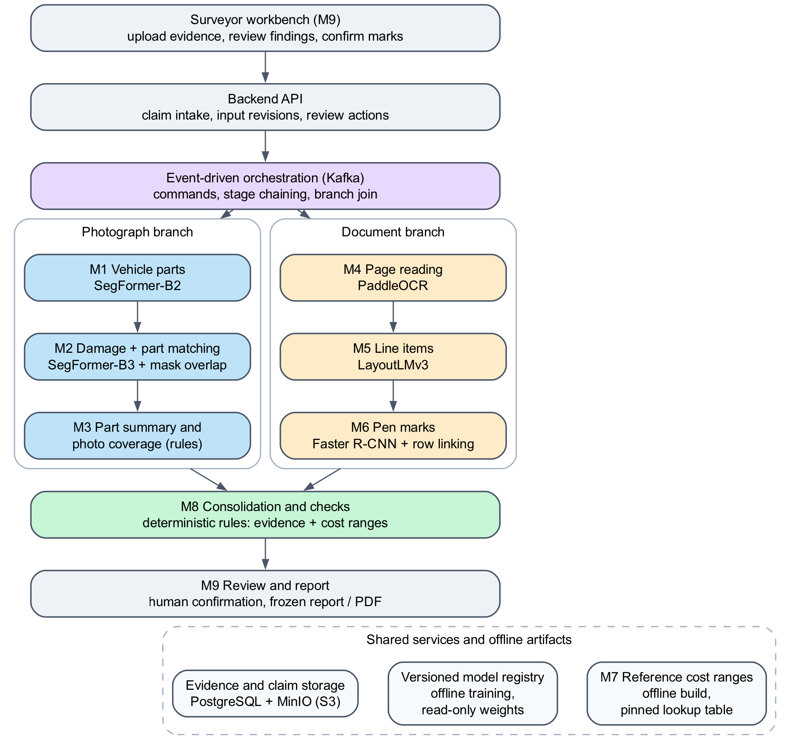
Figure 2.1. High-level architecture of CLAIM-CMEV

2.3 Modules and models
The system has nine modules (Table 2.2). Five use neural networks, two are deterministic rule engines, M7 is an offline statistical model and M9 is the user interface. Every neural model was fine-tuned from a public pretrained checkpoint, except the OCR model in M4, which is used as released. Chapters 3 to 8 describe how the models were trained and evaluated.
Table 2.2. Modules, methods and outputs
Module | Task | Method | Training data | Main output
M1 | Vehicle part segmentation | SegFormer-B2, fine-tuned | HITL car parts (21 parts) | Part mask for each photograph
M2 | Damage segmentation and part matching | SegFormer-B3, fine-tuned, plus mask-overlap rules | CarDD (6 damage types) | Damage observations assigned to parts
M3 | Part summary and photo coverage | Deterministic rules plus surveyor confirmation | None | Damage per part and a coverage state
M4 | Page reading | PaddleOCR, pretrained and not retrained | None | Corrected page and OCR text lines
M5 | Line-item extraction | LayoutLMv3-base, fine-tuned | 500 synthetic claim pages | Declared repair rows and amounts
M6 | Pen-mark recognition | Faster R-CNN ResNet-50 FPN, fine-tuned, plus row-linking rules | 500 synthetic claim pages | Pending marks linked to rows
M7 | Reference cost ranges | LightGBM quantile regression with conformal calibration, built offline | Synthetic repair prices | Pinned table of price ranges
M8 | Consolidation and checks | Deterministic rules | None | One finding per repair row
M9 | Review and report | React workbench and FastAPI service | None | Human decisions, revisions and a frozen report

2.4 Technical design and deployment
The system runs as a set of Docker containers started together with Docker Compose (Figure 2.2 and Table 2.3). Each model runs in a worker container and loads its weights once at start-up from a read-only model registry. Workers never call each other. Instead, the orchestrator sends a command through Kafka; the worker writes its results to the database and object store and then publishes a completion event. This keeps the modules independent and would let the heavier models move to separate hardware later.
In the configuration used for this project (the lean profile), one combined worker hosts both the orchestrator and the M8 checks. M1 to M3 share one image worker. M4, M5 and M6 run as three separate document workers. M4 has its own container image because PaddleOCR needs NumPy 1.x, while the PyTorch models use newer libraries; M5 and M6 share one image but run as separate containers. A full profile can split the orchestrator and the M8 consolidator into separate containers.
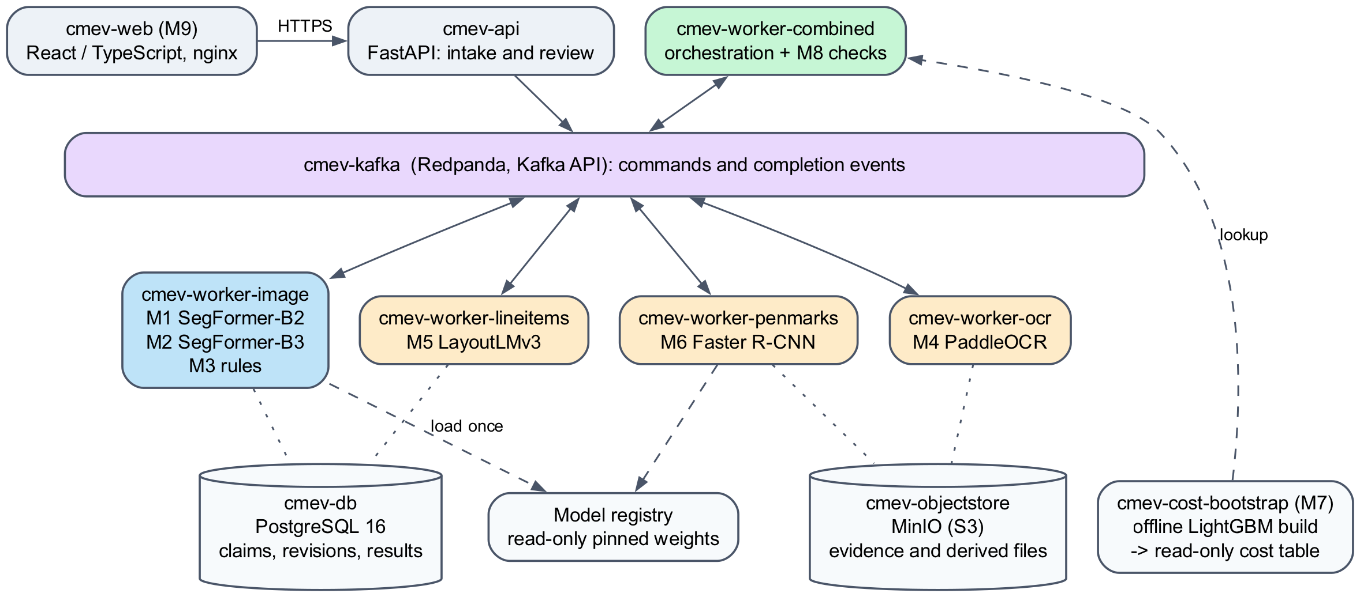
Figure 2.2. Containers of the live system and how they communicate
Table 2.3. Containers and their main technology
Container | Role | Main technology
cmev-web | Surveyor workbench (M9 user interface) | React, TypeScript, nginx
cmev-api | Claim intake, file upload, review actions and reports | Python, FastAPI, SQLAlchemy
cmev-worker-combined | Orchestration and M8 checks | Python; no model weights
cmev-worker-image | M1, M2 and M3 | PyTorch, Hugging Face Transformers (SegFormer)
cmev-worker-ocr | M4 page reading | PaddleOCR 2.10, PaddlePaddle 2.6, OpenCV
cmev-worker-lineitems | M5 line-item extraction | PyTorch, Transformers (LayoutLMv3)
cmev-worker-penmarks | M6 pen-mark detection and row linking | PyTorch, torchvision (Faster R-CNN)
cmev-kafka | Message broker for commands and events | Redpanda (Kafka-compatible)
cmev-db | Claims, revisions, results and job state | PostgreSQL 16
cmev-objectstore | Original evidence and derived files (masks, pages, overlays) | MinIO (S3-compatible)
cmev-cost-bootstrap | One-off M7 build of the reference cost table | Python, LightGBM

2.5 Processing flow for one claim
Figure 2.3 follows one claim through the system. After the upload, the API saves the input revision and an outbox event in a single database transaction, so a claim is never saved without its processing request. The orchestrator then starts both branches, which run in parallel. Inside each branch the stages run in order, because each stage needs the previous result: M2 matches damage to the part masks from M1, and M6 links marks to the rows from M5.
When every stage has finished, the orchestrator issues exactly one consolidate command, and M8 writes a new assessment that is never changed afterwards. If a stage still fails after its retries, the claim is marked incomplete instead of being assessed, and the results that did succeed stay readable. A claim with photographs but no estimate is still assessed, with the document branch marked as absent.
Messages are delivered at least once. Each job has a unique key, so a worker that receives the same command twice republishes its stored result instead of running the model again. Failed jobs are retried and then moved to a dead-letter topic with a reason code.
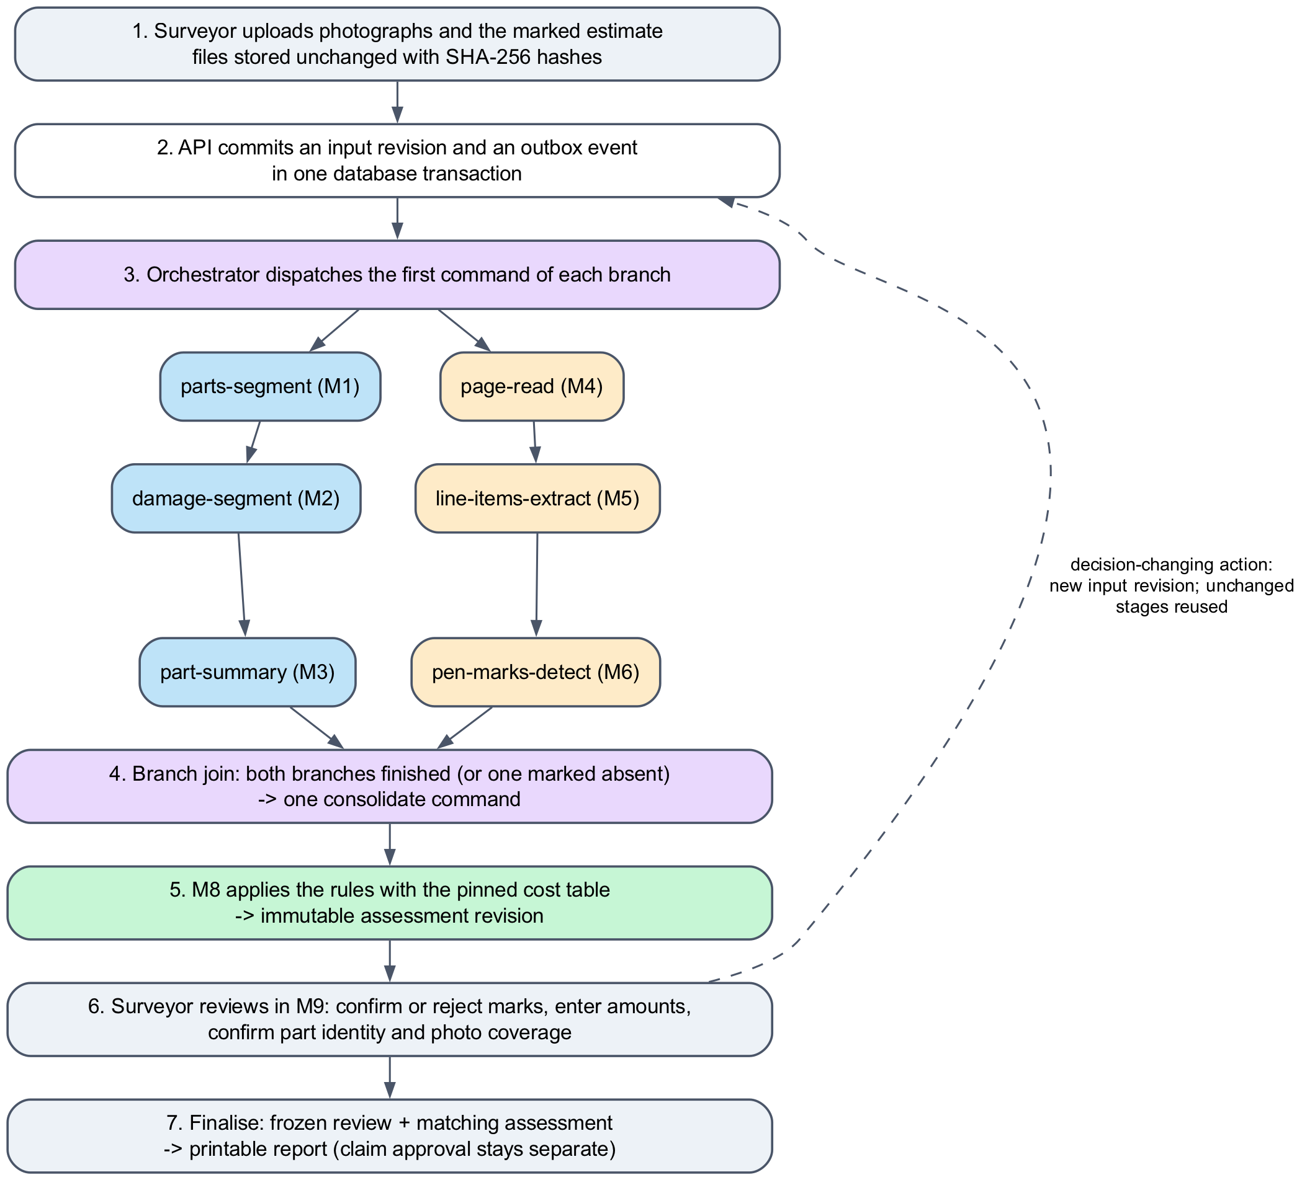
Figure 2.3. Processing flow for one claim, from upload to the frozen report

2.6 Decision rules and human review
M8 gives each declared repair row one of four results (Table 2.4). The rules look at three kinds of evidence. From the document, a row with a pending pen mark, an unreadable amount or an incomplete extraction cannot be judged. From the photographs, the part must be identified and adequately covered before the system may say that no damage is visible. For cost, the effective price is compared with the reference range for that part, operation and vehicle class. The effective price is the surveyor’s confirmed revised amount or, if there is no pen mark, the printed amount. A pending price change never falls back to the printed amount.
Table 2.4. M8 results shown to the surveyor
Result | Shown to the surveyor as | Meaning
ok | No discrepancy found | Damage is supported by the photographs and the price is within the reference range
unsupported | No supporting damage detected in adequate views | Part identified, photographs adequate, and no supported damage type detected
cost_outlier | Cost outside reference range | Damage is supported, but the effective price is outside the range
insufficient_evidence | More information needed | Pending mark, unresolved part or amount, incomplete extraction, uncertain damage, inadequate views or no reference range

Rows with a confirmed exclusion are not checked. M8 also lists possible additions: damaged parts seen in the photographs without a matching estimate row. These are only suggestions for the surveyor, and they are withheld when the estimate may be incomplete.
The surveyor works through these results in M9. Typical actions are confirming or rejecting a pen mark, entering a revised amount, correcting an extracted row, and confirming which physical part and side a photograph shows. Each decision-changing action creates a new input revision. The orchestrator reruns only the affected stages, reuses unchanged results and produces a new assessment, while earlier assessments stay as they were. When the review is complete, the surveyor finalises it, and the frozen review with its matching assessment produces a printable report. Final claim approval remains a separate decision by the insurer.

2.7 Data, storage and versioning
PostgreSQL holds the claims, input revisions, module results, assessments, review actions and job state. MinIO holds the original uploads, which are never modified, and derived files such as masks, corrected pages and overlays. Amounts are stored as exact decimals with an explicit currency and cost basis (SGD, one part, before tax and discounts). Every module result records the model, configuration, taxonomy and code versions that produced it, and every assessment pins the cost-table version it used. A past assessment can therefore be explained and reproduced even after a model or the cost table has changed.

2.8 Model development lifecycle
All training happens offline, in notebooks and scripts, separate from the running system (Figure 2.4). Datasets are converted to the project’s label sets and split into training, validation and test partitions, grouped so that related images or pages never fall in different partitions. Checkpoints and thresholds are chosen on validation data only. A selected run is exported as a registry entry that contains the weights, a manifest with SHA-256 hashes and the exact preprocessing settings. A configuration file then pins that version for serving.
At start-up each worker checks the weights, labels and preprocessing against the manifest and refuses to start if anything differs, so a mismatched model cannot silently produce results. M7 follows the same idea: its cost table is built offline and mounted read-only, so no pricing model runs while a claim is processed.
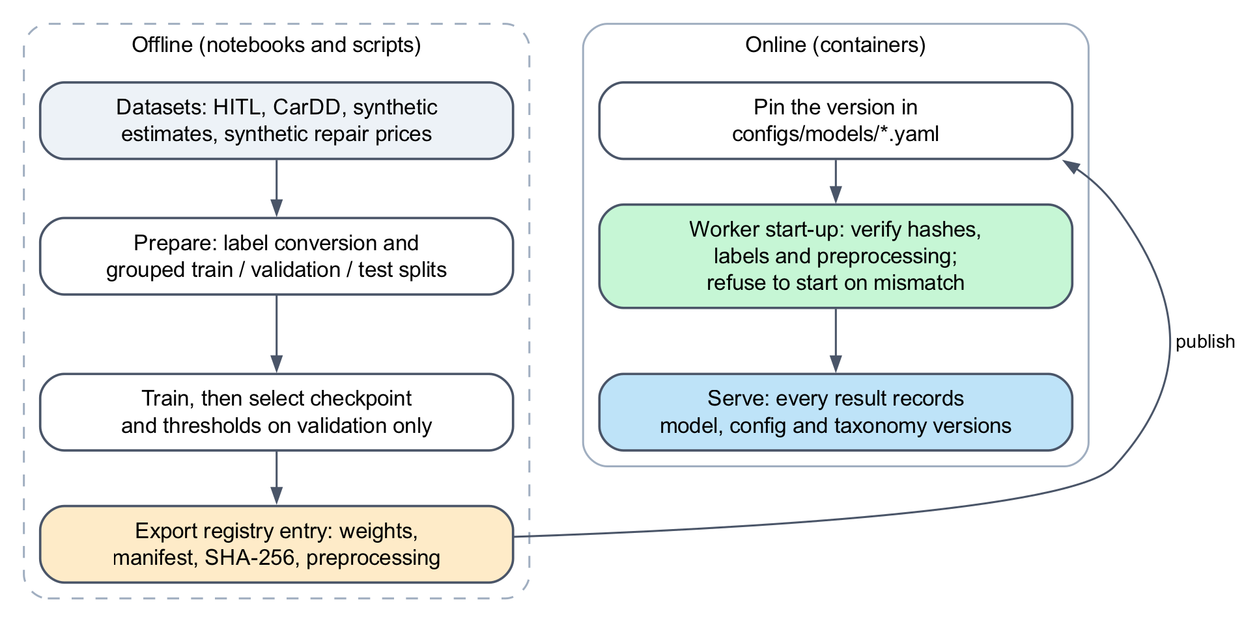
Figure 2.4. Model development lifecycle, from offline training to verified serving

2.9 Scope of the architecture
The architecture has been run end to end on public datasets and synthetic claim documents. Accuracy on real claims, production security and large-scale operation were outside the scope of this prototype. Repair-cost ranges are synthetic references, not validated market prices.

3. Module 1 (M1): Vehicle Part Segmentation

3.1 Executive Summary
Module 1 (M1) aimed to identify and segment vehicle parts from photographic images to support automated motor insurance claims assessment. The module was designed to generate pixel-level vehicle part masks that could subsequently be integrated with Module 2 (M2), which identifies damage types and their spatial locations.
Ten model configurations were evaluated across eight experimental phases, examining the effects of loss function optimisation, class imbalance correction, data augmentation, model capacity and segmentation architecture. The experiments were conducted using 147 held-out test images.
The findings demonstrated that weighted cross-entropy combined with Soft Dice loss improved the segmentation performance of SegFormer-B0, particularly for underrepresented vehicle parts. Increasing model capacity from SegFormer-B0 to SegFormer-B3 further improved performance. Among the evaluated architectures, YOLOv8m-seg achieved the highest foreground mean Intersection over Union (mIoU) of 0.7940, outperforming SegFormer-B3 (0.7303) and DeepLabV3-ResNet50 (0.7284). These findings suggest that an instance-based segmentation architecture may be particularly suitable for identifying vehicle parts with relatively distinct physical boundaries.
Overall, the results support the selection of YOLOv8m-seg as the preferred M1 architecture for subsequent integration with M2, subject to further evaluation of its performance within the complete damage-to-part assignment pipeline.

3.2 Key Findings
The M1 experiments produced four principal findings.
First, loss function optimisation improved segmentation performance, particularly for underrepresented vehicle parts. Replacing unweighted cross-entropy with weighted cross-entropy and Soft Dice loss increased SegFormer-B0 foreground mIoU from 0.4664 to 0.6034. The compound loss configuration also enabled all ten monitored vehicle part classes to achieve the predefined minimum IoU threshold of 0.40.
Second, increasing model capacity improved segmentation performance. SegFormer-B3 with compound loss achieved a foreground mIoU of 0.7303, compared with 0.6034 for SegFormer-B0 using the same loss formulation. This suggests that greater model capacity was beneficial for learning vehicle part characteristics and spatial boundaries.
Third, YOLOv8m-seg achieved the strongest overall segmentation performance, with a foreground mIoU of 0.7940 and supported-panel mIoU of 0.8086. It also demonstrated favourable performance for vehicle parts that were challenging for earlier SegFormer configurations, including the back door, roof and rocker panel.
Fourth, the experiments highlighted the importance of preserving uncertainty in vehicle part identification. Because the original dataset did not distinguish between left- and right-sided vehicle parts, the M1 pipeline retained the side designation as unknown rather than inferring orientation from incomplete annotations.

3.3 Dataset and Vehicle Part Taxonomy

3.3.1 Dataset provenance and preparation
The M1 experiments used the Car Parts and Car Damages Dataset developed by Humans in the Loop (HITL). An initial dataset audit identified an inconsistency in the naming of the source folders. The folder labelled Car damages dataset contained 998 images with vehicle part annotations, whereas the folder labelled Car parts dataset contained 814 images with damage annotations. The two subsets were therefore assigned to their respective modules based on annotation content rather than the original folder names. Out of the 998 images of the M1 dataset, 147 images were reserved for held-out testing.

3.3.2 Vehicle part taxonomy
The M1 dataset contained polygon annotations for 21 vehicle part categories. The experimental analysis focused particularly on ten supported vehicle parts representing major exterior body panels and structures, as shown in Table 1.
Table 1. Description of the ten selected vehicle parts and their associated segmentation challenges.
Vehicle Part | Description | Segmentation Challenge
Hood | Front engine compartment cover | Distinguishing boundaries near the grille and front bumper
Trunk | Rear luggage compartment lid | Curved boundaries adjacent to rear body panels
Front door | Front passenger entry panel | Confusion with adjacent rear door
Back door | Rear passenger entry panel | Boundary ambiguity at the front-door seam
Front bumper | Front impact assembly | Complex lower boundaries and grille regions
Back bumper | Rear impact assembly | Irregular boundaries around exhaust and diffuser areas
Quarter panel | Rear lateral body structure | Curved transitions into adjacent body structures
Fender | Front lateral body panel | Wheel-arch boundaries and adjacent panel transitions
Roof | Upper vehicle body panel | Limited visible area in certain viewing perspectives
Rocker panel | Lower body strip beneath doors | Narrow geometry and proximity to background regions

The dataset presented substantial class imbalance. Background pixels accounted for more than 70% of the image area, while some narrow vehicle structures represented less than 1%. This imbalance presented a challenge for segmentation models trained using conventional cross-entropy loss, as frequently occurring classes could dominate the optimisation process.

3.4 Experimental Stream

3.4.1 Experimental design
The M1 experiments evaluated ten model configurations across eight experimental phases. The experimental progression investigated four principal factors:
- Loss function optimisation to address class imbalance.
- Data augmentation to improve robustness to image variations.
- Model capacity scaling from SegFormer-B0 to SegFormer-B3.
- Architectural benchmarking across Transformer-based, CNN-based and instance-based segmentation approaches.

Performance was assessed using foreground mIoU, supported-panel mIoU and class-specific IoU. Foreground mIoU represents the average IoU across the foreground vehicle part classes, excluding background. Supported-panel mIoU represents the average IoU across the ten monitored vehicle parts. A predefined minimum IoU threshold of 0.40 was applied to each of the ten supported vehicle parts as an internal acceptance criterion.

3.4.2 Loss function optimisation
The initial SegFormer-B0 model was trained using unweighted categorical cross-entropy loss. Although this configuration achieved a foreground mIoU of 0.4664, three monitored vehicle parts failed to achieve the predefined minimum IoU of 0.40:
- Roof: 0.1316
- Rocker panel: 0.1224
- Back door: 0.2708

These results indicated that the baseline model experienced particular difficulties segmenting narrow or underrepresented structures and distinguishing adjacent door panels. To address these limitations, two alternative loss formulations were evaluated.

Weighted cross-entropy
Class weighting was introduced using the inverse square root of class frequency to increase the contribution of less frequently represented vehicle parts during training.
The weighted loss can be expressed as:
$$\boxed{L_{WCE}=-\frac{1}{N}\sum_{i=1}^{N}{w_{y_{i}}}\log\left(p_{i,y_{i}}\right)}$$
$L_{WCE}$ = Weighted cross-entropy loss
N = Total number of evaluated pixels
$i$ = Index of an individual pixel
$y_{i}$ = Ground-truth class label for pixel $i$
$w_{y_{i}}$ = Weight assigned to the ground-truth class $y_{i}$
$p_{i,y_{i}}$ = Predicted probability that pixel \(i\) belongs to its ground-truth class
$log$ = Natural logarithm

Class Weighting Formula
$$\boxed{w_{c}=\frac{1}{\sqrt{f_{c}}}}$$
Where:
$w_{c}$ = Weight assigned to vehicle part class c
$f_{c}$ = Relative frequency of pixels belonging to class \(c\) in the training dataset.

This configuration improved foreground mIoU from 0.4664 to 0.5897. However, the back door remained below the acceptance threshold, achieving an IoU of 0.3818.

Compound loss
The subsequent experiment combined weighted cross-entropy with Soft Dice loss. Soft Dice loss measures the overlap between predicted probability maps and ground-truth segmentation masks, encouraging spatial agreement between the predicted and actual regions.
A general compound loss formulation is:
$$\boxed{L_{compound}=λL_{WCE}+\left(1-λ\right)L_{Dice}}$$
$L_{compound}$ = Total compound loss
$L_{WCE}$ = Weighted cross-entropy loss
$L_{Dice}$ = Soft Dice loss
$λ$ = Weighting coefficient $0≤λ≤1$ controlling the relative contribution of the two loss components.

The compound loss configuration increased foreground mIoU to 0.6034 and enabled all ten monitored vehicle parts to achieve an IoU of at least 0.40. These findings suggest that combining class-weighted pixel classification with an overlap-based objective was beneficial for segmenting underrepresented vehicle structures.

3.4.3 Data augmentation
Data augmentation was subsequently introduced to examine whether exposure to greater image variability would improve segmentation performance. The augmentation strategy incorporated photometric adjustments and image scaling.
For SegFormer-B0, augmentation combined with compound loss produced a foreground mIoU of 0.5986, slightly below the 0.6034 achieved without augmentation. A similar pattern was observed for SegFormer-B2, where augmentation produced a foreground mIoU of 0.7062 compared with 0.7075 without augmentation.
These findings indicate that the evaluated augmentation strategy did not improve overall foreground mIoU. Nevertheless, both augmented configurations satisfied the predefined minimum IoU requirements for the ten supported vehicle parts.

3.4.4 Model capacity scaling
The next experimental phase examined whether increasing SegFormer model capacity improved segmentation performance. Three SegFormer configurations were evaluated:
- SegFormer-B0
- SegFormer-B2
- SegFormer-B3

Using compound loss, foreground mIoU increased progressively from 0.6034 for SegFormer-B0 to 0.7075 for SegFormer-B2 and 0.7303 for SegFormer-B3. The corresponding supported-panel mIoU increased from 0.5945 to 0.6914 and 0.7254, respectively. These results suggest that increasing model capacity was beneficial for learning more complex vehicle part representations, including curved structures and boundaries between adjacent panels. However, the improvements should be interpreted in relation to the additional computational requirements associated with larger architectures.

3.4.5 Multi-architecture benchmarking
Following the SegFormer ablation experiments, the strongest SegFormer configuration was compared with two alternative segmentation architectures:
- DeepLabV3-ResNet50
- YOLOv8m-seg

DeepLabV3-ResNet50 employs a CNN-based segmentation approach incorporating atrous spatial pyramid pooling to capture information at multiple spatial scales. YOLOv8m-seg uses an instance-based segmentation architecture that predicts object instances and their associated masks. The benchmark compared the three architectures using the same held-out test set.

3.4.6 Overall experimental results

Table 2. Performance across the ten M1 experimental configurations
Model Configuration | Foreground mIoU | Supported-Panel mIoU | Minimum IoU Criterion
SegFormer-B0, baseline CE | 0.4664 | 0.4710 | Failed: 3 classes
SegFormer-B0, weighted CE | 0.5897 | 0.5831 | Failed: 1 class
SegFormer-B0, compound loss | 0.6034 | 0.5945 | Passed
SegFormer-B0, augmentation + compound loss | 0.5986 | 0.5907 | Passed
SegFormer-B2, baseline CE | 0.6914 | 0.6789 | Passed
SegFormer-B2, compound loss | 0.7075 | 0.6914 | Passed
SegFormer-B2, augmentation + compound loss | 0.7062 | 0.6916 | Passed
SegFormer-B3, compound loss | 0.7303 | 0.7254 | Passed
DeepLabV3-ResNet50 | 0.7284 | 0.7357 | Passed
YOLOv8m-seg | 0.7940 | 0.8086 | Passed
SegFormer-B2 notebook, baseline recipe † | 0.6205 | 0.6615 | Passed
SegFormer-B2 notebook, augmentation, revised labels † | 0.7989 | 0.7905 | Passed
SegFormer-B2 notebook, augmentation, serving frame (deployed) † | 0.7857 | 0.7813 | Passed
† Runs from notebooks/M1_HITL_parts_training.ipynb, scored on the validation split, not on the test set used for the rows above. All three use plain cross-entropy (no Dice term or class weighting). The baseline run uses the first label version, low learning rates and only flip and brightness/contrast augmentation. The two augmentation runs add random scale and crop (0.5–2×), rotation (±10°) and colour jitter, with labels that keep nested polygons. The deployed run is trained in the serving worker’s image frame on the published 0.1.1 split and is the M1 model used by the live system. Because the evaluation split and labels differ, these rows are not directly comparable with the rows above.

YOLOv8m-seg achieved the highest foreground mIoU of 0.7940, outperforming SegFormer-B3 by 0.0637 and DeepLabV3-ResNet50 by 0.0656. All three final benchmark architectures satisfied the predefined minimum IoU criterion for the ten supported vehicle parts (refer to Table 2).

3.4.7 Per-panel segmentation performance
To examine performance differences across vehicle parts, class-specific IoU values were compared among the three final benchmark architectures (refer to Table 3).

Table 3. Per-panel IoU across the final M1 architectures
Vehicle Part | SegFormer-B3 | DeepLabV3-ResNet50 | YOLOv8m-seg | SegFormer-B2 (deployed) †
Hood | 0.8656 | 0.8830 | 0.9127 | 0.9290
Trunk | 0.7712 | 0.7274 | 0.8390 | 0.7502
Front door | 0.6695 | 0.7271 | 0.7947 | 0.7649
Back door | 0.6103 | 0.6850 | 0.7918 | 0.6773
Front bumper | 0.8234 | 0.8054 | 0.8423 | 0.8869
Back bumper | 0.8568 | 0.8433 | 0.8897 | 0.8709
Quarter panel | 0.7242 | 0.7177 | 0.8492 | 0.8044
Fender | 0.7471 | 0.7882 | 0.8719 | 0.8725
Roof | 0.5914 | 0.6087 | 0.6694 | 0.6144
Rocker panel | 0.5941 | 0.5712 | 0.6254 | 0.6428
Supported-panel mIoU | 0.7254 | 0.7357 | 0.8086 | 0.7813
† Deployed notebook model, scored on the validation split (145 images). The other three columns are test-set results and are not directly comparable.

YOLOv8m-seg achieved the highest IoU across all ten monitored vehicle parts. Particularly notable improvements were observed for the front door, back door and quarter panel, where accurate identification of boundaries between adjacent vehicle structures is important. The roof and rocker panel remained relatively challenging across the three architectures, although their IoU values were substantially higher than those achieved by the baseline SegFormer-B0 model.

3.4.8 Qualitative inspection
Qualitative inspection was conducted using representative test images to examine differences in segmentation boundaries and vehicle part identification. Three cases were selected:

Case 1: Door seam boundaries and rocker panel identification
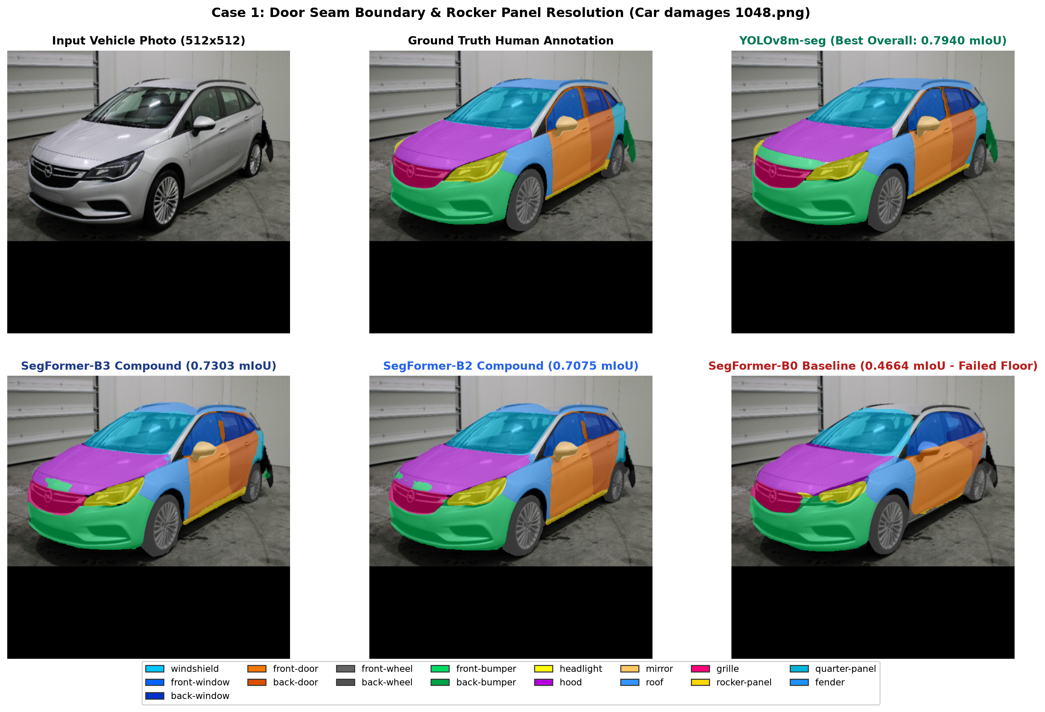
Figure 1. Door Seam Boundary Resolution & Rocker Panel Detection (Car damages 1048.png)

The baseline SegFormer-B0 configuration showed difficulties distinguishing the front-door and back-door boundaries and identifying the narrow rocker panel. SegFormer-B3 and YOLOv8m-seg demonstrated improved separation of adjacent doors, with YOLOv8m-seg producing visually sharper boundaries along the rocker panel (refer to Figure 2).

Case 2: Rear body assembly
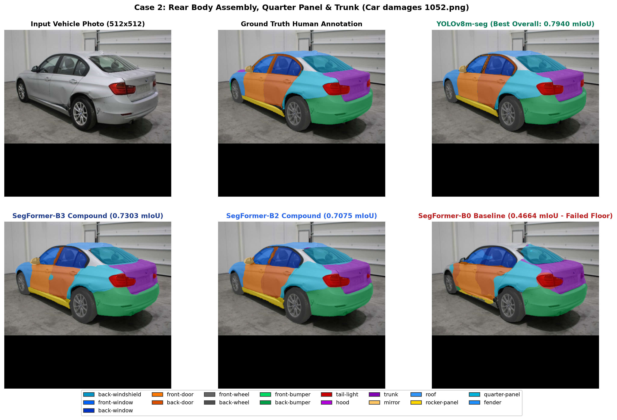
Figure 2. Rear Body Assembly, Quarter Panel & Trunk Demarcation (Car damages 1052.png)

This case examined segmentation of the trunk, quarter panel and adjacent rear body structures, where curved boundaries and overlapping visual features can complicate part identification (refer to Figure 3).

Case 3: Front collision profile
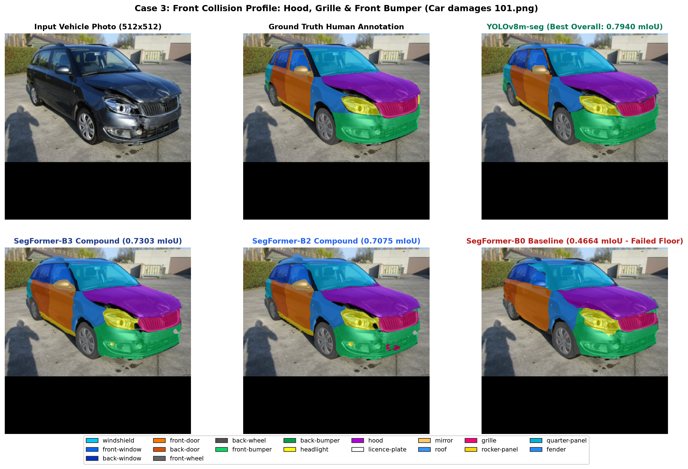
Figure 3. Front Collision Profile: Hood, Deformed Grille & Front Bumper (Car damages 101.png)

This case examined the segmentation of the hood, grille region and front bumper in a vehicle with visible collision damage. These qualitative comparisons complemented the quantitative evaluation by illustrating differences in predicted boundaries and the identification of vehicle structures under challenging photographic conditions (refer to Figure 4).

3.5 Discussion

3.5.1 Compound loss improved segmentation of underrepresented vehicle parts
The experiments demonstrated that loss function selection influenced M1 segmentation performance, particularly for underrepresented vehicle structures. Under unweighted cross-entropy, the baseline SegFormer-B0 model achieved relatively high IoU for frequently represented structures such as the hood but performed poorly for the roof, rocker panel and back door.
Introducing class weighting improved performance by increasing the contribution of less frequently represented classes during optimisation. The subsequent addition of Soft Dice loss further improved foreground mIoU and eliminated violations of the predefined minimum IoU threshold. These findings suggest that combining class-weighted cross-entropy with an overlap-based loss function may help address the effects of class imbalance in vehicle part segmentation.

3.5.2 Increasing model capacity improved SegFormer performance
Increasing SegFormer capacity from B0 to B3 was associated with progressive improvements in foreground mIoU. Using compound loss, SegFormer-B0 achieved a foreground mIoU of 0.6034, compared with 0.7075 for SegFormer-B2 and 0.7303 for SegFormer-B3.
These improvements suggest that larger models were better able to represent the spatial characteristics of vehicle parts, including curved surfaces, narrow structures and boundaries between adjacent panels.
However, greater model capacity also introduces additional computational requirements. Therefore, architecture selection should consider both segmentation performance and implementation feasibility.

3.5.3 YOLOv8m-seg was strongest for vehicle part segmentation
Among the final benchmark architectures, YOLOv8m-seg achieved the highest foreground mIoU (0.7940) and supported-panel mIoU (0.8086). Its performance was particularly favourable for adjacent vehicle structures, including the front and back doors, where earlier SegFormer configurations showed boundary confusion.
One possible explanation is that vehicle body panels generally represent discrete physical structures with relatively well-defined boundaries. YOLOv8m-seg's instance-based segmentation approach may be advantageous for identifying and separating these structures.
In contrast, semantic segmentation architectures predict class labels at the pixel level without necessarily distinguishing individual object instances. Nevertheless, the observed differences cannot be attributed solely to architectural design because other factors, including model capacity, training procedures and post-processing, may also influence performance.

3.5.4 Segmentation performance varied across vehicle parts
Although YOLOv8m-seg achieved the strongest overall performance, differences remained across vehicle part categories. The hood achieved the highest IoU of 0.9127, whereas the rocker panel and roof achieved lower values of 0.6254 and 0.6694, respectively. These differences may reflect variations in the visibility, size and geometry of vehicle structures.

For example, the rocker panel occupies a relatively narrow region beneath the doors, while the roof may be only partially visible depending on the photographic angle. These findings indicate that overall mIoU should be interpreted alongside class-specific performance, particularly when the downstream application requires accurate identification of individual vehicle parts.

3.5.5 Implications for M1–M2 integration
The purpose of M1 extends beyond identifying vehicle parts independently. Its segmentation masks provide the spatial information required to associate damage regions detected by M2 with specific vehicle structures. In the integrated pipeline, a damage component predicted by M2 is compared with the vehicle part masks predicted by M1 using a containment measure:
$$\boxed{C_{ij}=\frac{\left|D_{i}∩P_{j}\right|}{\left|D_{i}\right|}}$$
$C_{ij}$ = Containment score of damage component i within vehicle part j
$D_{i}$ = Predicted damage region identified by M2
$P_{j}$ = Predicted vehicle part region identified by M1
$\left|D_{i}∩P_{j}\right|$ = Number of pixels shared by the damage region and vehicle part region
$\left|D_{i}\right|$ = Total number of pixels in the damage region

Higher-quality vehicle part segmentation may improve the spatial correspondence between damage regions and vehicle parts, particularly near boundaries between adjacent panels. Based on the standalone segmentation benchmark, YOLOv8m-seg was selected as the preferred M1 architecture for integration with SegFormer-B3 for M2. However, the standalone performance of M1 does not necessarily determine the accuracy of the complete integration pipeline. Further evaluation using independently annotated damage-to-part ground truth is required to establish whether the preferred combination produces the most accurate assignments.

3.6 Limitations and implementation considerations
Several limitations should be considered when interpreting the findings.
First, the evaluation was conducted using 147 held-out test images from the HITL dataset. The generalisability of the findings to other vehicle types, photographic conditions and insurance claims settings remains to be established.
Second, the original annotations did not distinguish between left- and right-sided vehicle parts. Consequently, M1 could identify a vehicle part category but could not reliably determine its lateral orientation from the available labels. The pipeline therefore retained the side designation as unknown, requiring subsequent confirmation through additional information or human review.
Third, although YOLOv8m-seg achieved the highest segmentation performance, the experiments did not establish its comparative computational efficiency or cost-effectiveness in a production environment.
Finally, segmentation performance was evaluated primarily using pixel-level overlap metrics. These metrics do not directly establish whether the resulting vehicle part predictions are sufficiently accurate for downstream repair assessment.
Future evaluation should therefore consider assignment accuracy, computational requirements, implementation feasibility and cost-effectiveness, alongside segmentation performance.

3.7 Conclusion
The M1 experiments demonstrated that loss function optimisation and model capacity scaling improved vehicle part segmentation, particularly for underrepresented and geometrically challenging structures. Among the evaluated architectures, YOLOv8m-seg achieved the highest foreground mIoU of 0.7940, outperforming SegFormer-B3 and DeepLabV3-ResNet50. These findings support its selection as the preferred M1 architecture for integration with M2. However, further evaluation of damage-to-part assignment accuracy, implementation feasibility and cost-effectiveness is required before real-world deployment.

4.0 Module 2 (M2: Vehicle Damage Identification and Segmentation)
Multi-Label Damage Classification, Damage Segmentation, Architectural Benchmarking and Downstream Part-Matching Analysis

Table 4. Overview of M2 experimental specifications and benchmark models.
System Attribute | Specification / Value
Project | CLAIM-CMEV (Automated Insurance Estimate vs Photo Verification)
Pipeline Module | Module 2 (M2: Vehicle Damage Identification and Segmentation)
Authors | Lane 2 Vision Engineering Team & Pair Programming Team
Execution Date | October 2026
Dataset Source | HITL Supervisely Vehicle Damage Dataset
Total M2 Images | 814 vehicle images
Damage Taxonomy | 8 damage classes
Classification Architectures Evaluated | ResNet18, ResNet50, ViT-B/16
Segmentation Architectures Evaluated | SegFormer-B3, DeepLabV3-ResNet50, YOLOv8m-seg
M2 Classification Benchmark | ResNet50 + Weighted BCE
M2 Segmentation Benchmark | SegFormer-B3 + Compound Loss
System Attribute | Specification / Value

4.1 Executive Summary
Module 2 (M2) addresses the identification of vehicle damage from photographic evidence. Two related but distinct computer-vision approaches were investigated.
The first approach formulated M2 as whole-image multi-label classification, where a vehicle photograph could contain one or more of eight damage types. ResNet18, ResNet50 and ViT-B/16 were evaluated to investigate class weighting, augmentation, CNN capacity and Transformer-based image representation.
The second approach extended M2 to pixel-level damage segmentation, allowing the location and spatial extent of each predicted damage region to be identified. SegFormer-B3, DeepLabV3-ResNet50 and YOLOv8m-seg were benchmarked for this purpose.
These two approaches answer complementary questions:
- Classification
What type or types of damage are present in this photograph?
- Segmentation
What type of damage is present, and where is the damaged region?

The spatial information provided by segmentation is particularly important for downstream integration with M1 vehicle-part segmentation because damage masks can be spatially matched with vehicle-part masks.

4.2 Key findings
- Class weighting improved image-level damage classification
For ResNet18, replacing standard Binary Cross-Entropy (BCE) with weighted BCE increased validation Macro-F1 from 0.5429 to 0.5843.
- The evaluated augmentation strategy did not improve classification test performance
Although augmentation increased validation Macro-F1 to 0.5925, test Macro-F1 decreased slightly from 0.5266 to 0.5229.
- ResNet50 achieved the strongest image-level classification performance
ResNet50 with weighted BCE achieved a test Macro-F1 of 0.5684 and Micro-F1 of 0.7211, outperforming the evaluated ResNet18 and ViT-B/16 configurations.
- ViT-B/16 showed signs of overfitting
Its best validation Macro-F1 occurred at epoch 6 (0.4607). Training loss subsequently decreased substantially without corresponding validation improvement, and test Macro-F1 was 0.4243.
- SegFormer-B3 achieved the strongest pixel-level damage segmentation performance
SegFormer-B3 with compound loss achieved a foreground mIoU of 0.1576 and Macro F1 of 0.2501, compared with DeepLabV3-ResNet50 at 0.1234 mIoU and YOLOv8m-seg at 0.1106 mIoU.
- The segmentation formulation enables direct integration with M1
Predicted damage regions can be spatially compared with M1 vehicle-part masks using deterministic mask containment, enabling damage-to-part assignment rather than merely identifying which damage types are present in an entire photograph.

4.3 Dataset and Damage Taxonomy
The M2 dataset contains 814 vehicle images with damage polygon annotations covering eight damage categories. The source dataset audit also identified 441 images shared with the M1 dataset. In the integrated segmentation pipeline, image-content SHA-256 hashing was used to ensure that these shared images remained in corresponding data partitions, reducing the risk of cross-module evaluation leakage.
The eight M2 damage categories with the corresponding number of images containing each type of damage were:
- Missing part (n=434)
- Broken part (n=664)
- Scratch (n=517)
- Cracked (n=67)
- Dent (n=629)
- Flaking (n=108)
- Paint chip (n=279)
- Corrosion (n=109)

The damage categories were highly imbalanced, with substantially more examples of broken parts and dents than cracked, flaking and corrosion damage.

4.4 Experimental Stream A: Image-Level Multi-Label Damage Classification

4.4.1 Rationale
The initial M2 experiments investigated whether damage type could be identified directly from the complete vehicle photograph. Because more than one damage type may occur in the same photograph, M2 was formulated as a multi-label rather than single-label classification problem.
Each image was therefore associated with an eight-dimensional binary target:
$$y=\left[y_{1},y_{2},…,y_{8}\right], y_{i}∈\left\{0,1\right\}$$

where each element represents the presence or absence of one damage category.
The classification dataset was divided using multi-label stratification into:
- Training: 646 images
- Validation: 83 images
- Test: 85 images

Images were resized to 224 × 224 RGB before being passed to the classification architectures.

4.4.2 Classification Loss and Class-Imbalance Handling
Binary Cross-Entropy
Binary Cross-Entropy was selected because each damage class represents an independent binary prediction:
$$L=-\left[y\log\left(p\right)+\left(1-y\right)\log\left(1-p\right)\right]$$
where $y$ is the true binary label (0 or 1), and $p$ is the predicted probability that the class is present. BCE With Logits Loss was used to combine sigmoid transformation and BCE calculation.

Weighted Binary Cross-Entropy (BCE)
To address class imbalance, positive-class weights were subsequently calculated using the training dataset:
$$w_{c}=\frac{N-P_{c}}{P_{c}}$$
where $w_{c}$ is the weight assigned to damage category c, N is the total number of training images, and $P_{c}$ is the number of training images containing damage category c.

Damage type positive weight
Missing part | 0.862
Broken part | 0.217
Scratch | 0.564
Cracked | 10.963
Dent | 0.284
Flaking | 6.512
Paint chip | 1.897
Corrosion | 6.425
Missing part | 0.862

The considerably larger weights assigned to cracked, flaking and corrosion reflect their lower representation in the training dataset.

4.5 Classification Experimental Progression
Table 5 summarises the five M2 image-level damage classification experiments, comparing the effects of class weighting, data augmentation and model architecture on classification performance.
Table 5. Comparison of M2 image-level damage classification models and their performance
Experiment | Architecture / Intervention | Epochs | Valuation Macro-F1 | Test Macro-F1 | Test Micro-F1
0.1.0 | ResNet18 + BCE | 40 | 0.5429 | — | —
0.2.0 | ResNet18 + Weighted BCE | 40 | 0.5843 | 0.5266 | 0.6875
0.3.0 | ResNet18 + Weighted BCE + Augmentation | 40 | 0.5925 | 0.5229 | 0.6771
0.4.0 | ResNet50 + Weighted BCE | 40 | 0.5494 | 0.5684 | 0.7211
0.5.0 | ViT-B/16 + Weighted BCE | 40 | 0.4607 | 0.4243 | 0.5062

- Phase 1: ResNet18 Baseline
A pretrained ResNet18 with standard BCE established the initial baseline, achieving a validation Macro-F1 of 0.5429.
- Phase 2: Weighted BCE
Introducing class-weighted BCE increased the validation Macro-F1 from 0.5429 to 0.5843. On the test set, the model achieved a Macro-F1 of 0.5266 and a Micro-F1 of 0.6875. This supported retaining weighted BCE in subsequent experiments.

- Phase 3: Data Augmentation
The training images were augmented using random horizontal flipping, ±10° rotation, and colour jitter. The validation Macro-F1 increased slightly from 0.5843 to 0.5925. However, the test Macro-F1 decreased slightly from 0.5266 to 0.5229, while the Micro-F1 decreased from 0.6875 to 0.6771. The applied augmentation strategy therefore did not improve held-out test performance and was not retained for subsequent architecture comparisons.
- Phase 4: ResNet50
Increasing CNN capacity from ResNet18 to ResNet50 produced the strongest classification test performance among the evaluated models. The best checkpoint occurred at epoch 33, with a test Macro-F1 of 0.5684 and a test Micro-F1 of 0.7211.
- Phase 5: ViT-B/16
A pretrained Vision Transformer Base with 16 × 16 patches was evaluated using the same weighted BCE strategy. The best validation Macro-F1 of 0.4607 occurred at epoch 6. On the test set, the model achieved a Macro-F1 of 0.4243 and a Micro-F1 of 0.5062. Training loss subsequently continued to decrease while validation Macro-F1 plateaued, suggesting overfitting under the evaluated configuration.

4.5.1 ResNet50 Per-Class Classification Performance

Table 6. Class-specific performance of the M2 image-level damage classification model on the test set
Damage Type | Precision | Recall | F1 | Test Support
Missing part | 0.72 | 0.88 | 0.79 | 43
Broken part | 0.82 | 0.88 | 0.85 | 66
Scratch | 0.69 | 0.71 | 0.70 | 52
Cracked | 0.33 | 0.14 | 0.20 | 7
Dent | 0.77 | 0.85 | 0.81 | 65
Flaking | 0.30 | 0.27 | 0.29 | 11
Paint chip | 0.47 | 0.57 | 0.52 | 28
Corrosion | 0.44 | 0.36 | 0.40 | 11

The model performed particularly well for Broken part, Dent, Missing part and Scratch, while performance was substantially lower for Cracked, Flaking and Corrosion (Table 6). This pattern is consistent with the pronounced class imbalance observed in the dataset.

4.6 Experimental Stream B: Pixel-Level Damage Segmentation
While whole-image classification can identify the damage types present in a photograph, it does not directly identify the spatial location or extent of each damage.
M2 was therefore also formulated as a semantic/instance segmentation problem using the available damage polygon annotations.
The segmentation benchmark used:
- Training: 558 images
- Validation: 124 images
- Held-out test: 132 images
- Classes: 8 damage classes + background

The different split counts from the classification experiments reflect the union-hash-aligned splitting strategy used for the integrated M1-M2 pipeline. Three architectures were benchmarked (Table 7).
Table 7. Comparison of M2 damage segmentation architectures and their performance on the test set
Architecture | Parameters | Pixel Accuracy | Foreground mIoU | Macro Precision | Macro Recall | Macro F1
SegFormer-B3 + Compound Loss | 47.2M | 0.9463 | 0.1576 | 0.2582 | 0.2489 | 0.2501
DeepLabV3-ResNet50 + Compound Loss | 42.0M | 0.9404 | 0.1234 | 0.2178 | 0.1981 | 0.2027
YOLOv8m-seg | 27.2M | 0.9287 | 0.1106 | 0.2223 | 0.1735 | 0.1804
SegFormer-B3 achieved the strongest overall segmentation performance across the evaluated architectures.

4.6.1 Per-Class Damage Segmentation Performance

Table 8. Comparison of class-specific IoU across the three M2 damage segmentation architectures
Damage Class | SegFormer-B3 IoU | DeepLabV3 IoU | YOLOv8m-seg IoU
Background | 0.9539 | 0.9488 | 0.9364
Missing part | 0.2899 | 0.2596 | 0.2644
Broken part | 0.3043 | 0.2465 | 0.2518
Scratch | 0.1986 | 0.1095 | 0.0987
Cracked | 0.0000 | 0.0001 | 0.0000
Dent | 0.3323 | 0.2787 | 0.2437
Flaking | 0.0064 | 0.0385 | 0.0000
Paint chip | 0.0409 | 0.0283 | 0.0262
Corrosion | 0.0888 | 0.0263 | 0.0000

SegFormer-B3 achieved the highest IoU for six of the eight damage classes, including dent, broken part, missing part, scratch, paint chip and corrosion. Cracked remained particularly challenging across all architectures (Table 8).

4.7 Discussion: Classification Versus Segmentation Architecture Findings
The classification and segmentation experiments provide complementary insights into M2 architecture selection.

4.7.1 ResNet50 was strongest for image-level damage classification
Among the evaluated classification models, ResNet50 with weighted BCE produced the highest held-out test Macro-F1 (0.5684) and Micro-F1 (0.7211). The progression from ResNet18 to ResNet50 suggests that increased CNN capacity was beneficial for identifying damage characteristics at the whole-image level.
In contrast, ViT-B/16 achieved substantially lower classification performance and showed signs of overfitting. One possible explanation is that the relatively small classification training dataset provided insufficient data for the evaluated Transformer configuration to generalise as effectively as the pretrained CNN. Importantly, these results should not be interpreted as demonstrating that CNNs are universally superior to Transformers for vehicle-damage analysis.

4.7.2 SegFormer-B3 was strongest when spatial localisation was required
A different pattern emerged when the task changed from image-level classification to pixel-level segmentation. SegFormer-B3 achieved a foreground mIoU of 0.1576, compared with 0.1234 for DeepLabV3-ResNet50 and 0.1106 for YOLOv8m-seg.
The findings from the classification and segmentation experiments are not directly comparable because the models were designed to perform different tasks. Image-level classification determines the damage type(s) present in an image, whereas pixel-level segmentation identifies both the damage type and its spatial location. Thus, while the ResNet50 classification model determines whether visual evidence of a particular damage type is present within the image, SegFormer-B3 performs the more spatially demanding task of identifying which pixels correspond to each damage type.

4.7.3 Damage morphology may favour dense segmentation
Vehicle damage presents substantial spatial heterogeneity. Dents may form comparatively large regions, whereas scratches, corrosion, flaking and paint chips can occupy small, irregular or elongated areas.
The segmentation benchmark showed particularly clear differences for scratch. SegFormer-B3 achieved an IoU of 0.1986, compared with 0.1095 for DeepLabV3 and 0.0987 for YOLOv8m-seg. For corrosion, SegFormer achieved 0.0888, while YOLO produced no detected pixels.
The supplied benchmark report interprets this as an advantage of dense multi-scale segmentation for irregular surface damage compared with an object-proposal approach (refer to Figure 5 for an explanation).

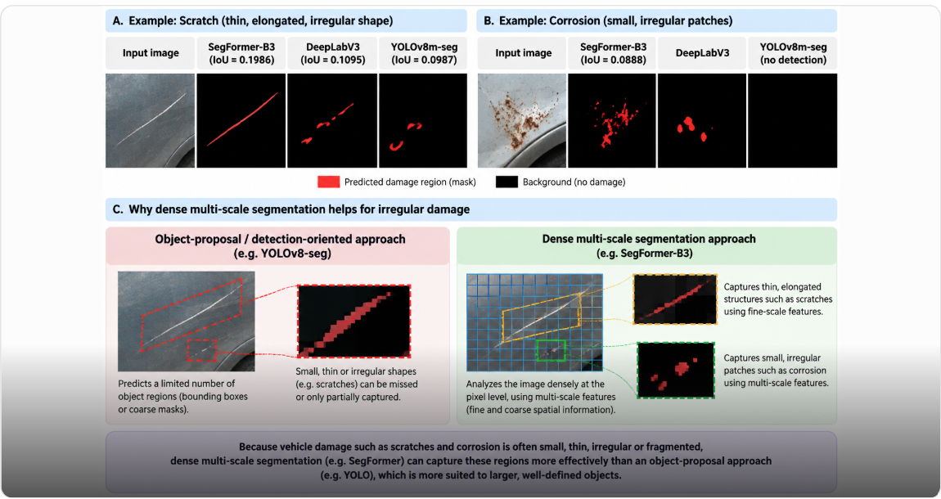
Figure 4. Dense multi-scale versus object-proposal segmentation of irregular vehicle damage.

4.7.4 Classification and segmentation results should not be directly ranked
The classification Macro-F1 of 0.5684 and segmentation Macro-F1 of 0.2501 should not be interpreted as evidence that ResNet50 is more accurate than SegFormer-B3.
They represent different prediction units:
- Classification F1 evaluates damage presence at image level.
- Segmentation F1 evaluates damage identification at pixel level.

Pixel-level segmentation is inherently more demanding because both the correct damage category and its spatial extent must be identified. Therefore, the two experimental streams are best regarded as complementary evidence rather than competing benchmarks.

4.7.5 Integration with M1 Vehicle-Part Segmentation
A major advantage of the segmentation formulation is its compatibility with M1.
M1 provides a predicted mask for a vehicle part, while M2 provides a predicted mask for a damage region. These can be spatially combined using the containment measure:

$$\text{Containment}=\frac{\left|\text{Damage Component}∩\text{Part Mask}\right|}{\left|\text{Damage Component}\right|}$$

The integrated pipeline applies a minimum primary containment of 0.60, a minimum difference of 0.20 between the primary and runner-up parts, and a maximum background containment of 0.50 before automatically assigning a damage region to a vehicle part.
This enables the pipeline to associate a damage type with a specific vehicle part, such as a dent on the front bumper or a scratch on the front door, rather than independently reporting the presence of a dent and a front door within the same image.

4.7.6 Damage-to-Part Assignment Performance
Using the standard configuration, M1 SegFormer-B3 combined with M2 SegFormer-B3 assigned 367 of 469 detected damage regions, corresponding to an assignment rate of 78.2% and a mean containment of 0.802.
M1 YOLOv8m-seg combined with M2 SegFormer-B3 assigned 363 of 469 regions, corresponding to an assignment rate of 77.4% and a mean containment of 0.811. Under the fine configuration, the assignment rates increased to 82.7% and 82.8%, respectively. Not all damage regions should necessarily be forced into a vehicle-part assignment. In the reported primary pairing, 102 of 469 regions remained unresolved, predominantly because the damage crossed the boundary between adjacent vehicle parts or did not reach the required containment threshold.
This approach therefore provides a mechanism for preserving uncertainty rather than forcing potentially incorrect damage-to-part assignments.

4.7.7 M2 Architectural Verdict
The M2 experiments demonstrate that the preferred architecture depends on the level of information required from the image.
- Image-Level Damage Identification
Among the evaluated classification configurations, ResNet50 with weighted BCE achieved the strongest test performance, with a Macro-F1 of 0.5684 and a Micro-F1 of 0.7211.
These findings indicate that ResNet50 was the strongest evaluated architecture for identifying the presence of damage types at the whole-image level.
- Spatial Damage Identification
For pixel-level damage localisation, SegFormer-B3 with compound loss achieved the strongest segmentation performance, with a foreground mIoU of 0.1576 and a Macro-F1 of 0.2501.
Its predicted damage masks provide spatial information on the location and extent of detected damage, which can subsequently support integration with vehicle-part segmentation.

4.8. Overall Conclusion
The M2 investigation demonstrates an important distinction between recognising vehicle damage and localising vehicle damage. Whole-image multi-label classification showed that damage types can be identified from complete vehicle photographs, with ResNet50 outperforming the evaluated ResNet18 and ViT-B/16 configurations. Weighted BCE improved performance relative to standard BCE, while the evaluated augmentation strategy did not improve held-out test performance.
Pixel-level segmentation addresses this limitation by providing spatial information on detected damage. Among the evaluated segmentation architectures, SegFormer-B3 achieved the strongest overall segmentation performance and performed better than the other evaluated architectures for several damage classes, including scratches and corrosion.
Accordingly, the findings support a complementary interpretation: ResNet50 was the strongest evaluated model for image-level damage classification, whereas SegFormer-B3 was the strongest evaluated model for spatial damage segmentation. For the subsequent CLAIM-CMEV pipeline, the segmentation-based M2 output provides the spatial information required for integration with vehicle-part segmentation. The methodology and performance of this integration are evaluated separately in the M1–M2 integration analysis.
The ResNet18, ResNet50, and ViT-B/16 classification experiments nevertheless provide useful supporting evidence regarding architecture selection, class-imbalance handling, and the distinction between image-level recognition and spatially resolved damage analysis.

5.0 Module 1 & Module 2 Comprehensive Benchmarking & Architectural Analysis
Multi-Architecture Evaluation (YOLOv8m-seg vs SegFormer-B3 vs DeepLabV3-ResNet50), Deterministic Part Assignment, and Downstream Cascading Framework
Table 9 summarises the experimental setup and dataset specifications, including the computing environment, hardware configuration, dataset composition and data splitting strategy. The dataset comprised 814 vehicle damage images, divided into training (558), validation (124) and test (132) sets using SHA-256 content hashing to prevent data leakage.
Table 9. Overview of experimental setup and dataset specifications
Attribute | Value
Project | CLAIM-CMEV (Automated Insurance Estimate vs Photo Verification)
Authors | Antigravity (Lane 1 Vision Engineering) & Pair Programming Team
Execution Date | October 4, 2026 (Asia/Singapore)
Target Workstation | Linux, Python 3.12, PyTorch 2.14.0+cu130, CUDA 13.0
GPU Hardware | NVIDIA GeForce RTX 5060 Laptop GPU (8,123 MiB VRAM, Compute 12.0)
Dataset Cohort | 814 Vehicle Damage Images (HITL Supervisely Dataset, 441 Union Hash Aligned)
Split Strategy | Disjoint Train (558), Val (124), Test (132) via SHA256 Union Hashing (Seed: 20260922)

5.1 Executive Summary
This report presents the end-to-end development, implementation, and comparative evaluation of two computer vision modules: Module 1 (M1), which focuses on vehicle part segmentation, and Module 2 (M2), which focuses on vehicle damage segmentation and its association with specific vehicle parts. Three deep learning architectures - YOLOv8m-seg, SegFormer-B3 with compound loss, and DeepLabV3-ResNet50 with compound loss were systematically trained and evaluated using consistent training, validation, and test data splits, with measures implemented to prevent data leakage. The performance of the different architectures was compared to identify the most suitable model for each module. Subsequently, different combinations of M1 and M2 models were evaluated using a deterministic mask-containment approach to assess their ability to associate detected damage regions with specific vehicle parts.

5.2 Key Findings
The integration of Module 1 (M1: Vehicle Part Segmentation) and Module 2 (M2: Vehicle Damage Segmentation) was evaluated to determine the feasibility of automatically associating detected vehicle damage with specific vehicle parts. The integrated pipeline combined predicted vehicle part masks from M1 with damage segmentation masks from M2 using a deterministic spatial containment approach.
Three computer vision architectures - YOLOv8m-seg, SegFormer-B3, and DeepLabV3-ResNet50 were evaluated in different M1-M2 combinations. The integration experiments were conducted using 132 held-out M2 test images, with the following key findings.
- The highest automated assignment rate under the standard configuration was achieved by combining SegFormer-B3 for both modules. This configuration successfully assigned 367 of 469 detected damage regions to vehicle parts, corresponding to an assignment rate of 78.2% and a mean primary containment of 0.802. The combination of YOLOv8m-seg for M1 and SegFormer-B3 for M2 achieved a comparable assignment rate of 77.4% (363 of 469 regions), with a slightly higher mean primary containment of 0.811.
- Automated assignment rates varied across model combinations. Although the YOLOv8m-seg combination for both modules achieved the highest assignment rate of 81.7% under the standard configuration, it identified substantially fewer damage regions (202) than configurations using SegFormer-B3 for M2 (469). Therefore, assignment rate alone should not determine the preferred model combination, as it does not account for the number or accuracy of detected damage regions.
- Reducing the minimum damage component size improved automated assignment rates. When the minimum component size was reduced from 256 to 64 pixels, the SegFormer-B3 combination for both modules achieved an assignment rate of 82.7% (710 of 859 regions), while YOLOv8m-seg for M1 combined with SegFormer-B3 for M2 achieved 82.8% (711 of 859 regions). However, this configuration also increased the number of detected components, potentially introducing additional small or fragmented damage regions.
- Unresolved damage regions were predominantly associated with overlapping vehicle parts. In the primary SegFormer-B3 combination, 102 of 469 damage regions (21.8%) remained unresolved. Most were classified as ambiguous between adjacent vehicle parts (69.6%), followed by regions that did not meet the minimum containment threshold (24.5%). These findings indicate that damage extending across multiple vehicle parts presents a particular challenge for automated assignment.
- Seam-guided splitting improved automated assignment rates but introduced potential risks. Under the standard splitting policy, the assignment rate increased from 78.2% to 90.8%. However, splitting also generated small fragments that could incorrectly be interpreted as independent damage to adjacent vehicle parts. Consequently, the baseline configuration retained unresolved damage regions for subsequent review rather than automatically assigning them to potentially incorrect parts.

Overall, the findings support the feasibility of integrating vehicle part and damage segmentation models to automate damage-to-part association. However, the results also highlight the importance of balancing automated assignment rates with the reliability of damage identification and the management of ambiguous observations.

5.3 Dataset and Damage Taxonomy

5.3.1 Dataset Sources
The integration experiments used the Car Parts and Car Damages Dataset developed by HITL. The dataset comprised two subsets containing polygon annotations for vehicle parts and damage types, respectively.
An initial dataset audit identified an inconsistency in the naming of the source folders. The folder labelled Car damages dataset contained 998 images with vehicle part annotations, whereas the folder labelled Car parts dataset contained 814 images with damage annotations (Table 10). The two subsets were therefore assigned to their respective modules based on their annotation content rather than the original folder names.

Characteristic | M1: Vehicle Part Segmentation | M2: Vehicle Damage Segmentation
Original dataset folder | Car damages dataset | Car parts datasetz
Total images | 998 | 814
Annotation type | Vehicle part polygons | Damage polygons
Number of foreground classes | 21 | 8
Background class | 0 | 0
Training images | 678 | 558
Validation images | 173 | 124
Test images | 147 | 132
Annotation format | 8-bit indexed PNG masks | 8-bit PNG masks
Table 10. Dataset characteristics

5.3.2 Data Splitting and Leakage Prevention
To minimise the risk of data leakage, the datasets were partitioned using a content-based hashing procedure. Each image was assigned a unique hash value using SHA-256, allowing identical images appearing in both datasets to be identified regardless of their filenames or folder locations. Train, validation, and test splits were generated using the combined image inventory and a fixed random seed of 20260922. All 441 shared images were assigned to the same data partition in both datasets, achieving 100% alignment. This procedure prevented identical images from appearing in the training partition of one module and the test partition of the other, thereby reducing the risk of data leakage during cross-module evaluation.

5.3.3 Vehicle Part and Damage Taxonomy
M1 and M2 used separate segmentation taxonomies.
M1 identified 21 vehicle parts, including major structural and exterior components such as the front bumper, rear bumper, bonnet, boot, doors, fenders, roof, and quarter panels.
M2 identified eight damage categories: missing part, broken part, scratch, cracked, dent, flaking, paint chip, and corrosion.
For integration, the predicted masks from both modules were mapped onto a common spatial grid. This enabled damage regions identified by M2 to be compared with the corresponding vehicle part regions identified by M1. Importantly, the integration process did not require retraining either segmentation model. Instead, the independently generated predictions were combined using spatial overlap rules.

5.4 Experimental Stream

5.4.1 Overview of the Integration Pipeline
The integration pipeline was designed to associate damage regions detected by M2 with vehicle parts identified by M1. Both modules independently processed vehicle photographs and generated segmentation masks representing their respective prediction categories.
The resulting masks were aligned on a common 512 × 512-pixel grid. For each connected damage component identified by M2, the pipeline calculated the proportion of its area overlapping each predicted vehicle part mask from M1.
The vehicle part with the greatest overlap was considered the primary candidate for assignment. However, assignment was performed only when predefined criteria were satisfied. Otherwise, the damage component remained unresolved (Figure 6).
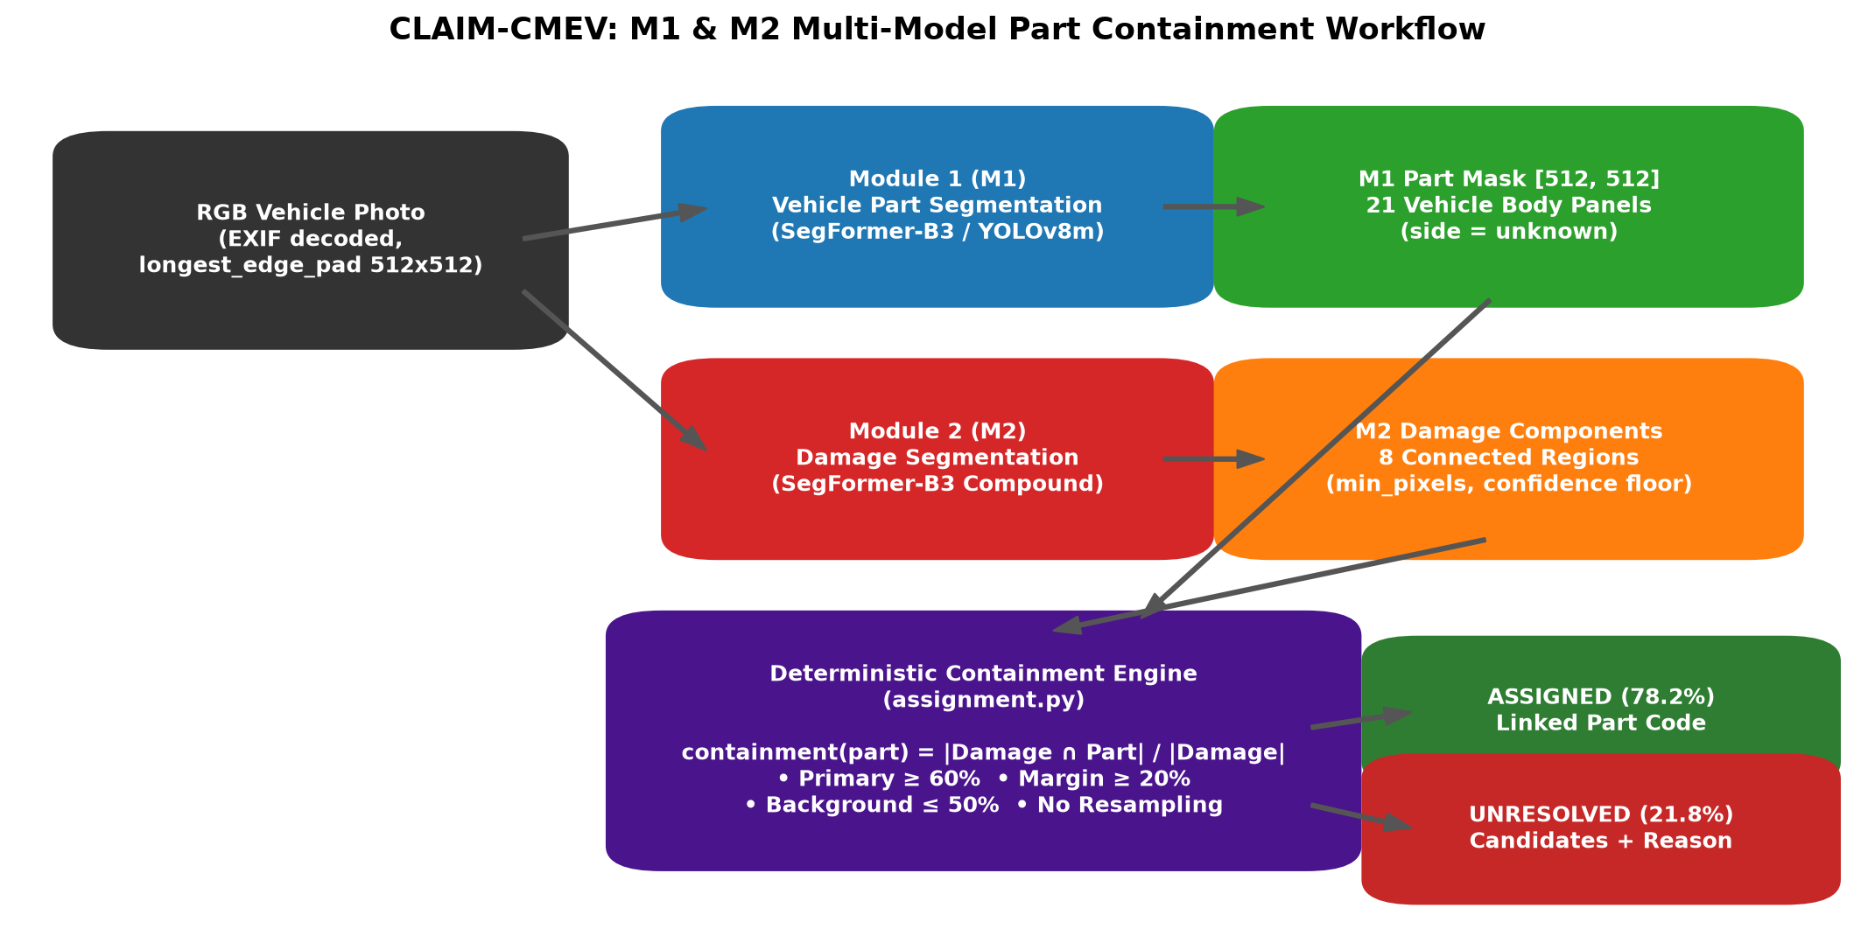
Figure 5. Deterministic Multi-Model Part Containment Workflow

5.4.2 Deterministic Damage-to-Part Assignment
The spatial relationship between a detected damage region and a vehicle part was quantified using the containment ratio:
$$\boxed{C_{ij}=\frac{\left|D_{i}∩P_{j}\right|}{\left|D_{i}\right|}}$$
where:
$C_{ij}$ = Containment ratio of damage component \(i\) within vehicle part \(j\).
$D_{i}$ = Set of pixels belonging to damage component \(i\).
$P_{j}$ = Set of pixels belonging to vehicle part \(j\).
$\left|D_{i}∩P_{j}\right|$ = Number of pixels shared by the damage component and vehicle part.
$\left|D_{i}\right|$ = Total number of pixels in the damage component.

A containment ratio of 1.0 indicates that the entire damage component lies within the predicted vehicle part, whereas a value of 0 indicates no overlap. For example, if a scratch contains 1,000 pixels and 800 pixels overlap the front bumper, the containment ratio for the front bumper is:
$$\boxed{C=\frac{800}{1000}=0.80}$$
This indicates that 80% of the detected scratch lies within the front bumper.
The assignment process applied four criteria:
Criteria | Threshold
Minimum primary containment | The highest containment ratio must be at least 0.60.
Minimum ambiguity margin | The difference between the highest and second-highest containment ratios must be at least 0.20.
Maximum background containment | No more than 50% of the damage component may overlap the background.
Valid vehicle part | The selected part must belong to the accepted vehicle part taxonomy.

Damage regions that did not satisfy these criteria were retained as unresolved, together with their candidate vehicle parts and corresponding containment ratios. This approach was intended to reduce incorrect assignments, particularly when damage extended across adjacent vehicle parts.

5.4.3 Cross-Architecture Integration Benchmark
Six combinations of M1 and M2 segmentation architectures were evaluated using the standard configuration, which required a minimum damage component size of 256 pixels. The evaluation was conducted using 132 held-out test images.
Table 11. Cross-architecture damage-to-part assignment performance
M1 Architecture | M2 Architecture | Detected Regions | Assigned Regions | Assignment Rate (%) | Mean Primary Containment | Mean Background Containment
SegFormer-B3 | SegFormer-B3 | 469 | 367 | 78.2 | 0.802 | 0.030
YOLOv8m-seg | SegFormer-B3 | 469 | 363 | 77.4 | 0.811 | 0.052
SegFormer-B3 | DeepLabV3-ResNet50 | 349 | 268 | 76.8 | 0.795 | 0.022
YOLOv8m-seg | DeepLabV3-ResNet50 | 349 | 270 | 77.4 | 0.803 | 0.041
YOLOv8m-seg | YOLOv8m-seg | 202 | 165 | 81.7 | 0.830 | 0.055
SegFormer-B3 | YOLOv8m-seg | 202 | 160 | 79.2 | 0.789 | 0.036

The SegFormer-B3 combination for both modules achieved an assignment rate of 78.2%, successfully associating 367 of 469 detected damage regions with vehicle parts. On the other hand, the combination of YOLOv8m-seg for M1 and SegFormer-B3 for M2 achieved a comparable assignment rate of 77.4%, assigning 363 damage regions. Although the YOLOv8m-seg combination for both modules achieved the highest assignment rate of 81.7%, it detected only 202 damage regions (Table 11). This difference is important because the assignment rate represents the proportion of detected damage regions successfully associated with vehicle parts, rather than the proportion of all actual damage regions correctly identified and assigned. Consequently, a model that detects fewer damage regions may achieve a higher assignment rate without necessarily providing more comprehensive damage assessment.

5.4.4 Sensitivity Analysis: Minimum Damage Component Size
A sensitivity analysis examined the effect of reducing the minimum damage component size from 256 to 64 pixels. The analysis focused on two model combinations using SegFormer-B3 for M2.
Table 12. Effect of minimum component size on assignment performance
M1 Architecture | M2 Architecture | Minimum Component Size | Detected Regions | Assigned Regions | Assignment Rate (%)
SegFormer-B3 | SegFormer-B3 | 256 px | 469 | 367 | 78.2
YOLOv8m-seg | SegFormer-B3 | 256 px | 469 | 363 | 77.4
SegFormer-B3 | SegFormer-B3 | 64 px | 859 | 710 | 82.7
YOLOv8m-seg | SegFormer-B3 | 64 px | 859 | 711 | 82.8

Reducing the minimum component size increased the number of detected damage regions from 469 to 859. The assignment rate also increased, reaching 82.7% for the SegFormer-B3 combination and 82.8% for the YOLOv8m-seg–SegFormer-B3 combination.
These findings suggest that smaller damage components can be successfully associated with vehicle parts. However, reducing the component size threshold may also increase the number of fragmented regions or false-positive detections. Therefore, the higher assignment rates should be interpreted alongside the potential implications for downstream claims assessment.

5.4.5 Analysis of Unresolved Damage Regions
Further analysis was conducted on unresolved damage regions generated by the SegFormer-B3 combination for both modules under the standard configuration. Of the 469 detected damage regions, 367 were successfully assigned, while 102 remained unresolved (Table 13).

Table 13. Distribution of unresolved damage regions
Reason for Unresolved Assignment | Number | Percentage (%)
Ambiguous between vehicle parts | 71 | 69.6
Below minimum containment threshold | 25 | 24.5
Excessive background overlap | 5 | 4.9
No vehicle part overlap | 1 | 1.0
Total | 102 | 100.0

Most unresolved regions were associated with ambiguity between adjacent vehicle parts. Three representative cases were examined to illustrate the different causes of unresolved assignment.

Case 1: Ambiguous damage between adjacent vehicle parts
In Car damages 1091.jpg, a dent measuring 492 pixels extended across the boundary between the front door and front fender. The containment ratios were 53.9% for the front door and 46.1% for the front fender. Although the front door had the highest containment, the difference between the two parts was only 7.8 percentage points, below the required 20% margin. Consequently, the damage remained unresolved, with both vehicle parts retained as potential candidates (Figure 7).
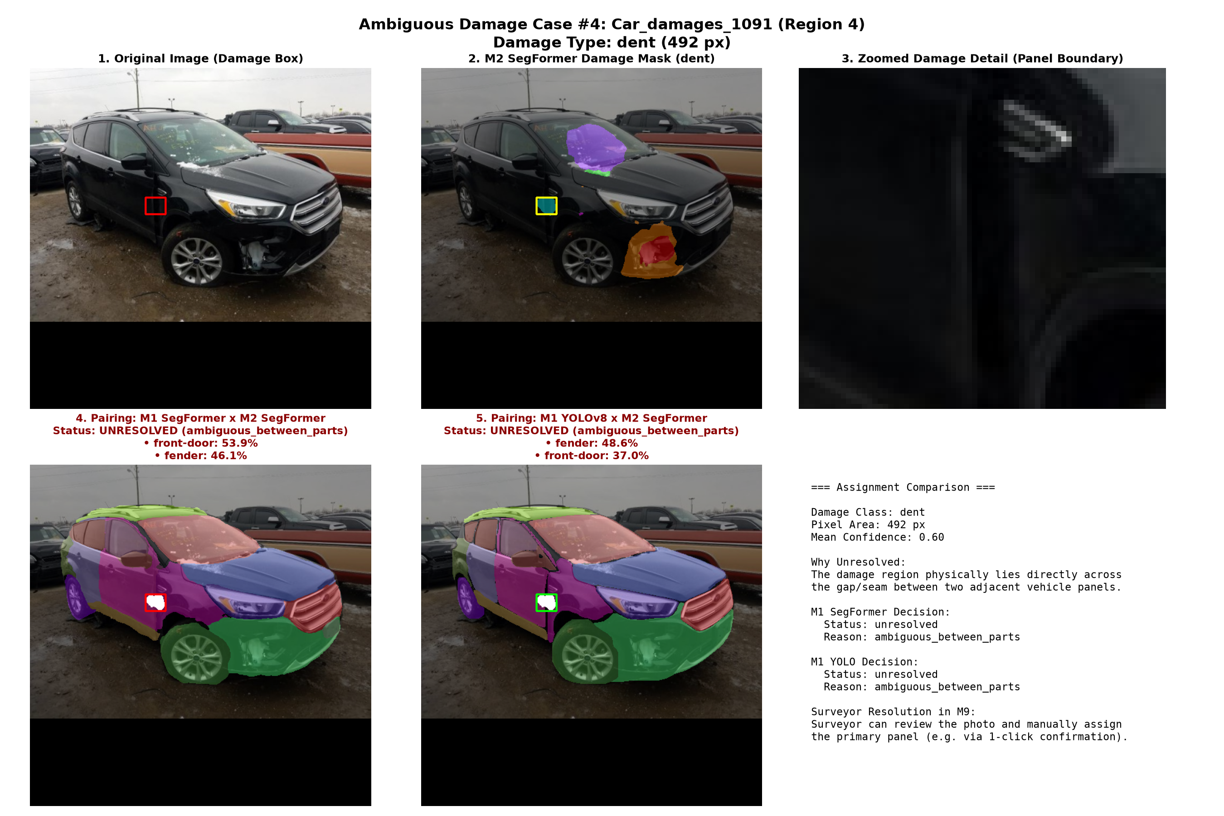
Figure: Ambiguous Between Parts: Door/Fender Seam Dent
Figure 6. Ambiguous Damage Between Front Door and Fender

Case 2: Damage extending across multiple vehicle parts
In Car damages 1184.png, a severe frontal collision produced a damage component covering approximately 30,250 pixels. The front bumper accounted for 57.3% of the component, followed by the headlight (15.7%) and grille (10.2%). Although the front bumper was the dominant part, its containment ratio was below the required threshold of 60% (Figure 8). The damage was therefore classified as unresolved.
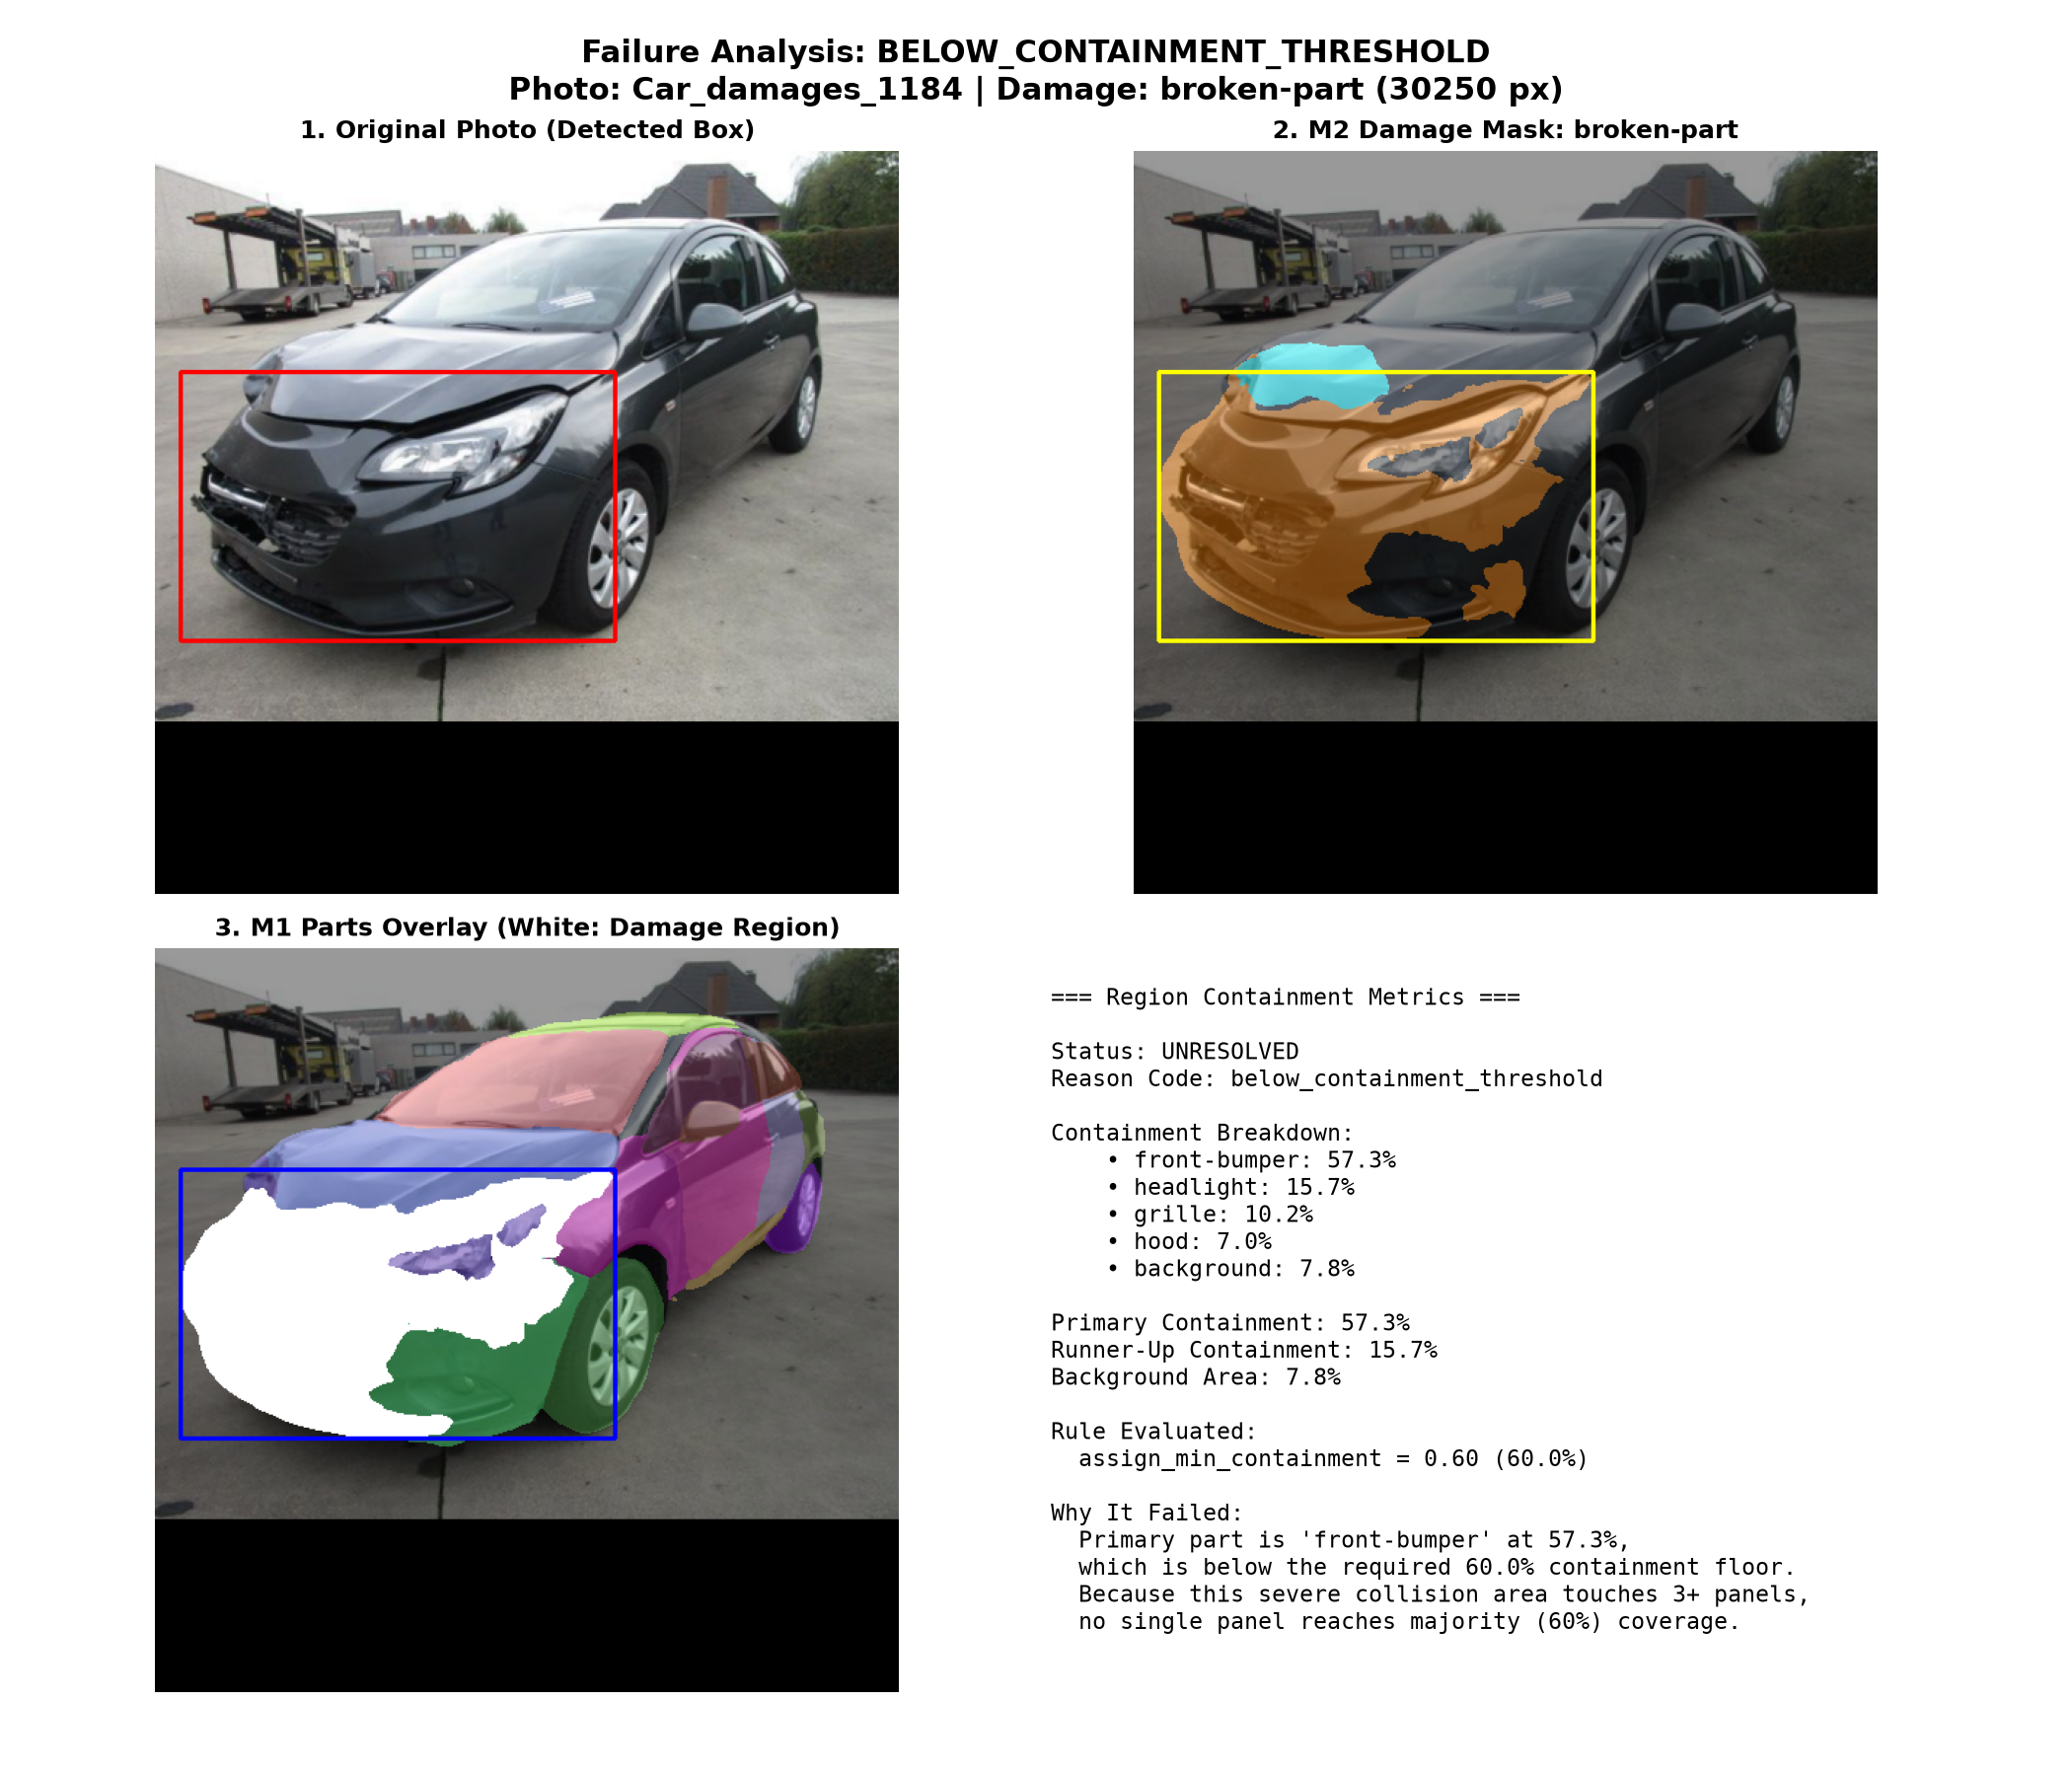
Figure 7. Multi-Panel Damage Below the Minimum Containment Threshold

Case 3: Excessive background overlap
In Car damages 394.png, the damage segmentation model incorrectly identified a region associated with overhead shadows. Approximately 89.4% of the detected component overlapped the background (Figure 9). The background containment criterion prevented the region from being automatically assigned to a vehicle part.

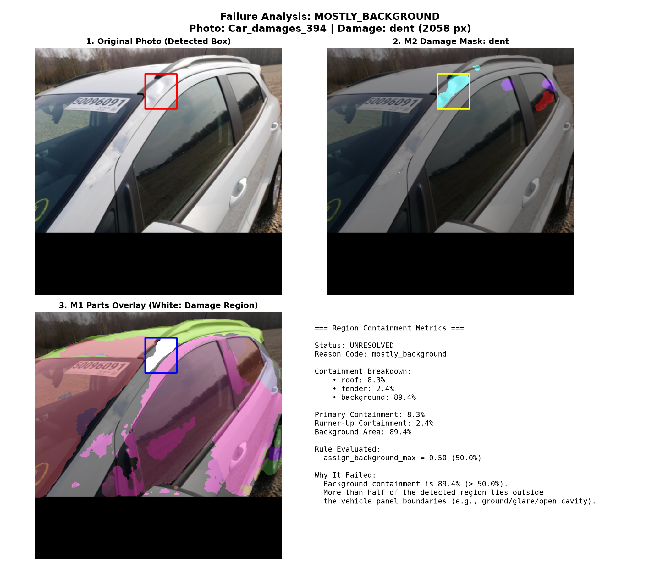
Figure 8. Background Containment Filtering of a False-Positive Detection

These cases demonstrate how the containment criteria can prevent uncertain damage observations from being automatically associated with potentially incorrect vehicle parts.

5.4.6 Seam-Guided Component Splitting Experiment
The baseline integration pipeline treated each connected damage component as a single observation, even when the component extended across multiple vehicle parts. This approach resulted in 71 unresolved components classified as ambiguous between adjacent parts. To investigate whether these ambiguities could be reduced, a seam-guided component splitting experiment was conducted. Seam-guided component splitting involves dividing a detected damage region into smaller components based on the vehicle part boundaries identified by M1, allowing each component to be evaluated separately for assignment to a vehicle part. The experiment evaluated three splitting policies against the baseline configuration using the SegFormer-B3 combination for both modules.

Table 14. Seam-guided splitting calibration results
Configuration | Minimum Subcomponent Area | Total Observations |  | Split Operations |  | Small Fragments (<15%) | Assigned Observations | Assignment  Rate (%) | Remaining Ambiguous Regions
Baseline: No splitting | - |  | 469 |  | 0 | 0 | 367 | 78.2 | 71
Conservative splitting | 500 px |  | 537 |  | 37 | 23 | 472 | 87.9 | 34
Standard splitting | 256 px |  | 564 |  | 50 | 34 | 512 | 90.8 | 21
Aggressive splitting | 128 px |  | 604 |  | 68 | 51 | 570 | 94.4 | 3

Enabling splitting increased the assignment rate from 78.2% without splitting to 87.9%, 90.8%, and 94.4% under conservative, standard, and aggressive configurations, respectively. However, these increases were accompanied by a rise in the number of small fragments, from 23 under conservative splitting to 51 under aggressive splitting (Table 14). Figure 10 and 11 show the examples. Furthermore, splitting changed the total number of components evaluated, meaning that higher assignment rates do not necessarily indicate greater assignment accuracy. These findings suggest that seam-guided splitting may improve assignment coverage, but additional validation against ground-truth damage-to-part associations is required before routine implementation.
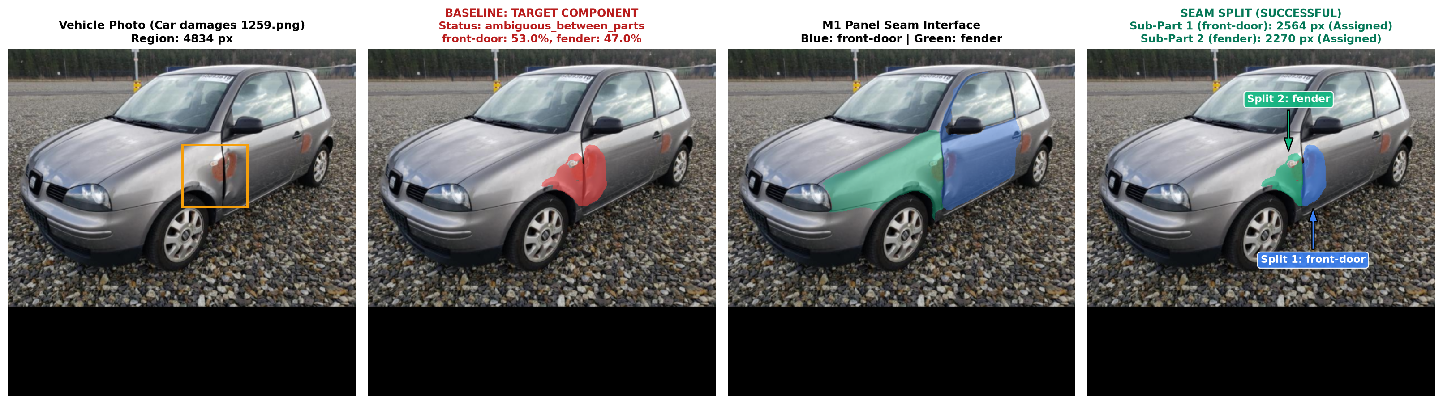
Figure 9. Seam-Guided Splitting of Multi-Panel Damage
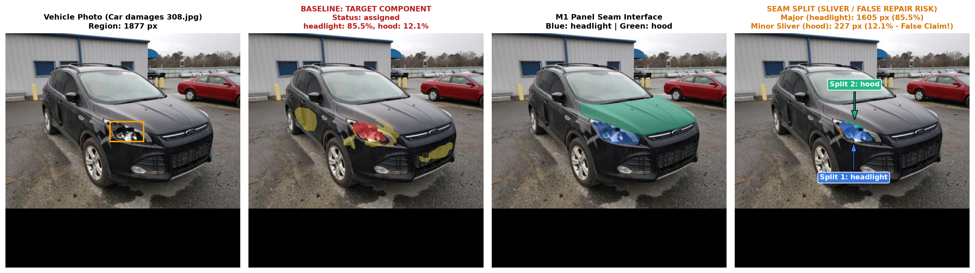
Figure 10. Example of Small Fragment Generation Following Splitting

The findings indicate that seam-guided splitting can improve automated assignment but may also introduce additional damage observations that require verification.

5.5 Discussion

5.5.1 Feasibility of Integrating Independently Trained Segmentation Models
The integration experiments demonstrated the feasibility of combining independently trained vehicle part and damage segmentation models through spatial containment analysis. By aligning the predicted masks from M1 and M2, the pipeline was able to associate a substantial proportion of detected damage regions with specific vehicle parts without requiring a jointly trained model. Under the standard configuration, the two model combinations using SegFormer-B3 for M2 achieved assignment rates of 78.2% (M1 SegFormer-B3) and 77.4% (M1 YOLOv8m-seg). These findings suggest that independently developed segmentation models can provide complementary information for automated vehicle damage assessment. However, the performance of the integrated pipeline depends on the accuracy of both segmentation modules. Errors in vehicle part boundaries or damage localisation may affect containment calculations and subsequent assignments. Therefore, successfully assigning a detected damage region to a vehicle part does not necessarily mean that the damage was correctly detected or that the vehicle part was correctly identified.

5.5.2 Selection of the Preferred Model Combination
Although the YOLOv8m-seg combination for both modules achieved the highest standard assignment rate of 81.7%, it detected substantially fewer damage regions than configurations using SegFormer-B3 for M2. This highlights an important limitation of using assignment rate as the sole criterion for model selection. The assignment rate measures the proportion of detected regions that satisfy the containment criteria. It does not measure the accuracy or completeness of damage detection. A model that identifies fewer damage regions may produce a higher assignment rate simply because the detected regions are larger or easier to associate with vehicle parts. Consequently, model selection should consider both the upstream segmentation performance and the downstream assignment results.
The SegFormer-B3 combination for both modules achieved the highest number of assigned regions under the standard configuration (367), while the YOLOv8m-seg–SegFormer-B3 combination achieved a comparable result (363). Given the stronger standalone M1 segmentation performance of YOLOv8m-seg and the stronger standalone M2 segmentation performance of SegFormer-B3, the YOLOv8m-seg–SegFormer-B3 combination represents a reasonable candidate for implementation. Nevertheless, the SegFormer-B3 combination for both modules remains a competitive alternative and achieved a slightly higher assignment rate in the standard integration benchmark. Further evaluation using independently annotated damage-to-part ground truth would be required to determine which model combination provides the most accurate assignments, while also considering implementation feasibility and cost-effectiveness to inform its suitability for real-world deployment.

5.5.3 Challenges of Damage Extending Across Multiple Vehicle Parts
However, the generation of small fragments through seam-guided splitting presents an important consideration. For example, a damage region primarily affecting the headlight may extend slightly into the adjacent bonnet. If this overlap represents genuine damage, splitting could facilitate more accurate identification of the affected vehicle parts. Conversely, if the overlap results from segmentation inaccuracies, splitting could incorrectly identify additional damaged parts, potentially influencing subsequent repair evaluations and cost estimates. To manage such uncertainties, the integration pipeline incorporated predefined containment thresholds, retaining damage components that failed to satisfy the assignment criteria as unresolved rather than automatically assigning them to the most likely vehicle part. This deterministic approach provides a transparent and reproducible method for integrating segmentation outputs, with containment offering an interpretable measure of the spatial relationship between damage regions and vehicle parts. Retaining unresolved observations also allows potentially relevant photographic evidence to be preserved for further review. For future implementation, a human-in-the-loop approach could enable surveyors to review and confirm ambiguous damage-to-part assignments, particularly those involving damage spanning multiple vehicle parts or small fragments generated through splitting. This would help balance the efficiency of automated assignment with the need for accurate and reliable damage assessment.

5.6 Conclusion
The integration experiments demonstrated the feasibility of combining independently trained vehicle part and damage segmentation models to associate detected damage with specific vehicle parts. The SegFormer-B3 combination for both modules achieved an assignment rate of 78.2%, comparable to the 77.4% achieved by YOLOv8m-seg for M1 and SegFormer-B3 for M2. Although other combinations achieved higher assignment rates, differences in the number of detected damage regions highlight the need to consider both detection and assignment performance. Seam-guided splitting improved assignment coverage but introduced potential inaccuracies associated with small fragments. Overall, the findings support a deterministic, uncertainty-aware integration approach that incorporates human review of ambiguous cases. The integrated pipeline provides a foundation for structured vehicle damage assessment and future repair cost benchmarking applications.

6.0 Module 4 (M4): Page Reading (Rodel)

6.1 Role in the document branch
The document branch reads the surveyor-marked workshop estimate in three steps (Figure 11). M4 turns each uploaded page into a corrected image and located OCR text. M5 labels that text and assembles the declared repair rows. M6 finds the surveyor’s pen marks and links them to those rows. Each module stores its records and images before it publishes a Kafka completion event, and the next module reads only these stored, hash-verified results. M8 then applies deterministic rules, and the surveyor decides every mark in M9 (ACERY, 2026d).
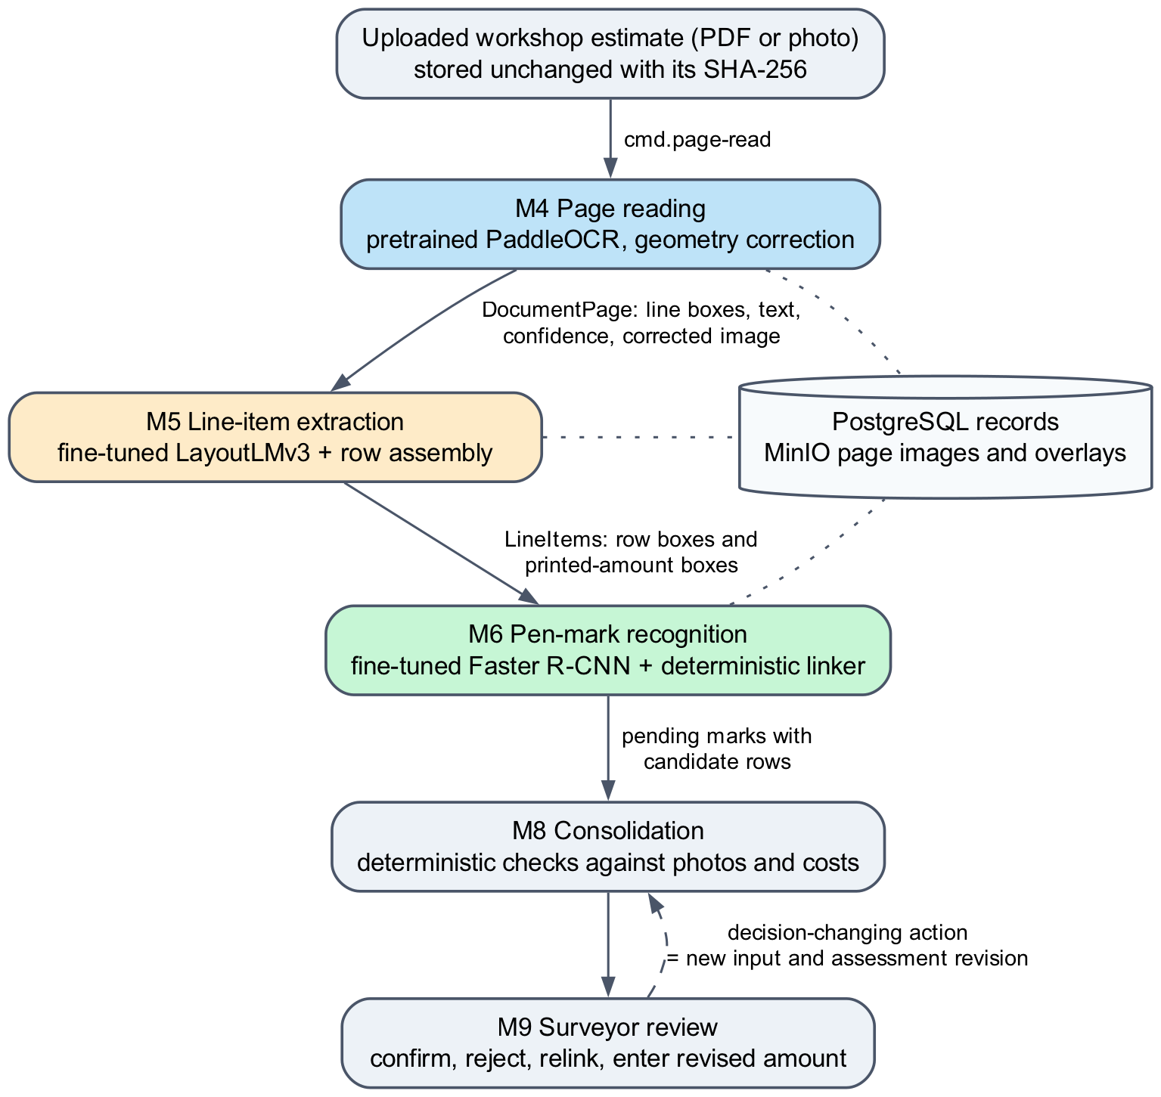
Figure 11. Document branch from upload to surveyor review

6.2 Pretrained OCR model
M4 uses pretrained English PaddleOCR 2.10.0 running on PaddlePaddle 2.6.2 (Table 15). PaddleOCR works in three stages: a detector finds text lines, an orientation classifier corrects upside-down text, and a recogniser reads the characters of each line. The official inference weights are downloaded once, checked against SHA-256 hashes in configs/models/ocr-manifest.json and mounted read-only into the cmev-worker-ocr container. No project-specific OCR training was performed, so M4 has no training data of its own (PaddleOCR contributors, n.d.).
Table 15. Pretrained OCR components used by M4
Stage | Model or software | Role
Text detection | en_PP-OCRv3_det_infer | Finds text lines and returns a four-corner box for each
Orientation | ch_ppocr_mobile_v2.0_cls_infer | Detects text turned by 180° and corrects it
Recognition | en_PP-OCRv4_rec_infer | Reads the characters of each line and returns a confidence score
Runtime | PaddleOCR 2.10.0, PaddlePaddle 2.6.2, CPU | Separate Linux container; weights verified at start-up

6.3 Processing workflow
Figure 12 shows the steps for one page. The worker first checks the uploaded file’s hash and skips commands for superseded claim revisions. PDFs are rasterised at 300 dpi, and photographs are rotated according to their EXIF orientation. OpenCV then looks for the page boundary. The page is warped to a flat rectangle only when the boundary is reliable: it covers at least 35% of the image and every corner is within 20° of a right angle. Otherwise M4 applies at most a small rotation, because a wrong warp would distort the table geometry that M5 and M6 depend on. The forward and inverse transforms are stored, so every box can be mapped back to the original upload.
PaddleOCR then runs on the corrected page and returns line-level text boxes. M4 checks that this granularity matches the configured value and never splits a line into invented word boxes. Each box keeps its original text, engine confidence, reading order and coordinates in both the corrected and the original frame. Quality signals such as sharpness, glare, contrast and resolution then set the page status (Table 16). An unreadable page fails with a reason code; it is never treated as a page without repair items.
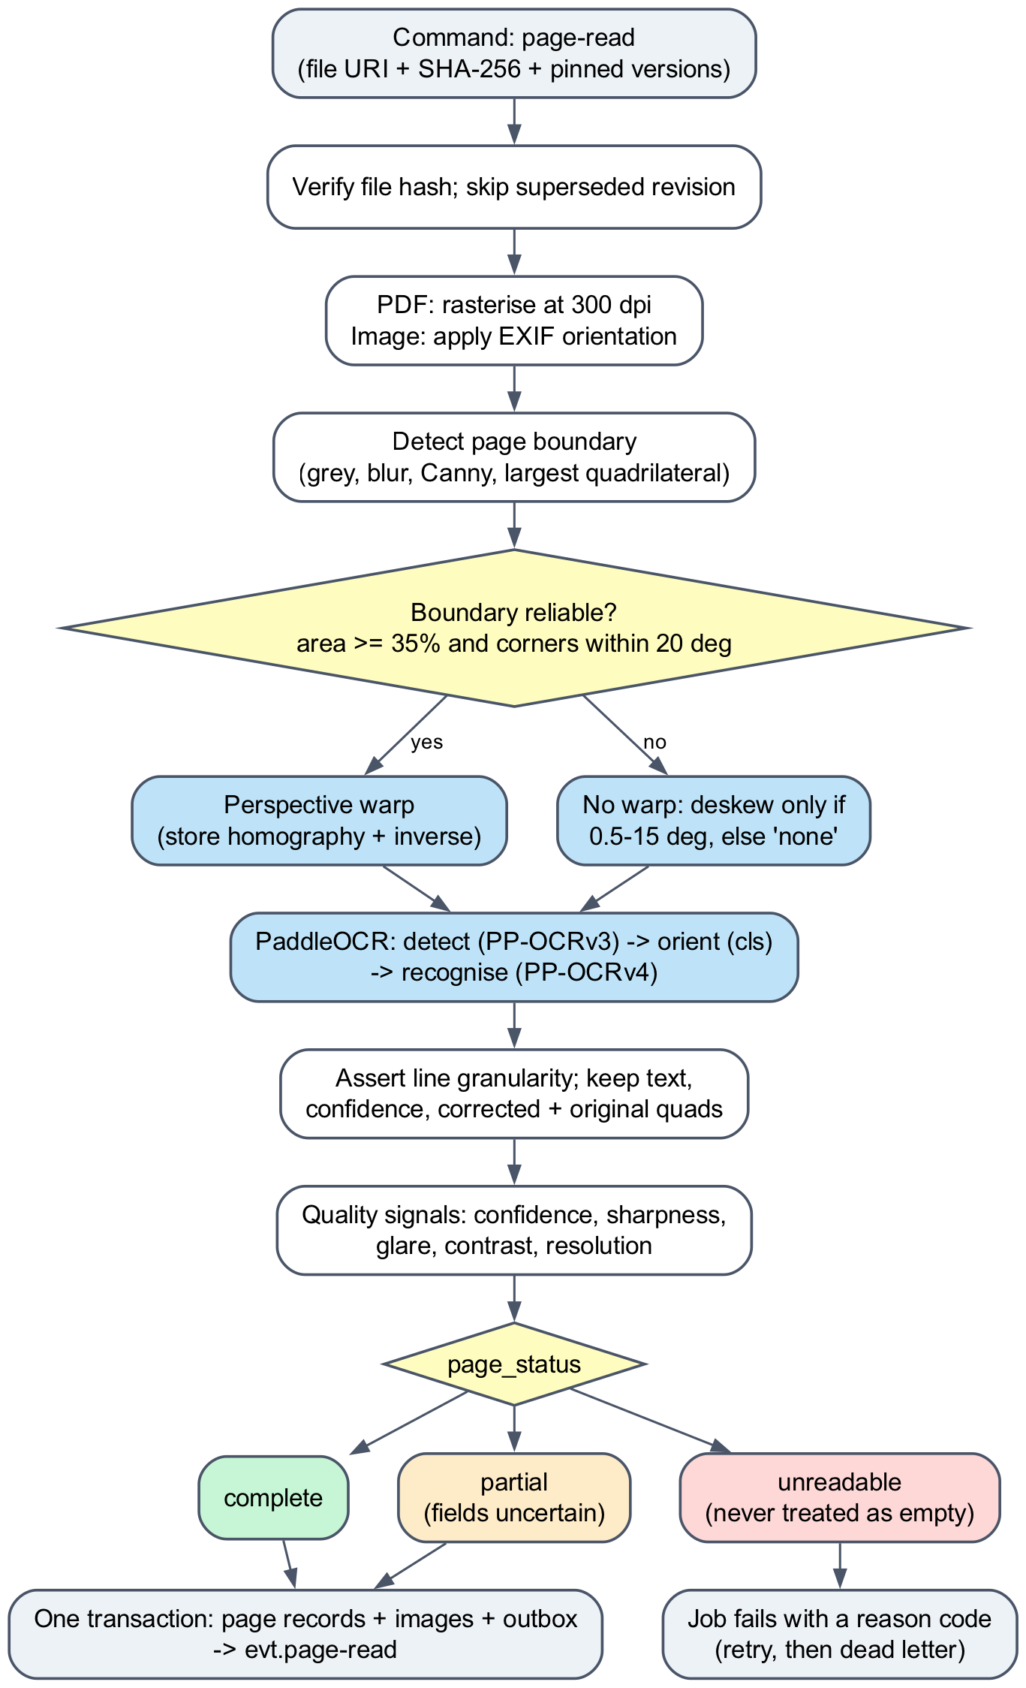
Figure 12. M4 page-reading workflow for one page
Table 16. M4 page status rules (configs/pipeline/m4_page_reading.yaml)
Condition | Page status | Effect downstream
Rasterising or decoding failed | unreadable | Job fails with a reason; the page is never read as empty
OCR failed or returned no boxes | unreadable | As above
Returned granularity differs from the configured line granularity | unreadable | Reason granularity_mismatch; needs a configuration fix
More than 15% of boxes below confidence 0.50, or a quality flag (blur, glare, uneven light, low contrast, low resolution) | partial | M5 may build rows but marks affected fields uncertain
All checks within thresholds | complete | Normal processing

6.4 Output and handoff to M5 and M6
Each page produces a DocumentPage record: the corrected image, the located text lines with their confidence, the transforms and the page status (Figure 13). Records, images and the outbox event are written in one database transaction, so M5 never reads a half-written page. To train M5 and M6 on exactly what serving produces, the real M4 adapter was run once, inside the same Linux image, over all 500 synthetic pages. The resulting cache stores every DocumentPage with file hashes (Table 17). Both training notebooks load this cache, so their models learn from real OCR errors and box geometry rather than from ideal annotation boxes (ACERY, 2026a).
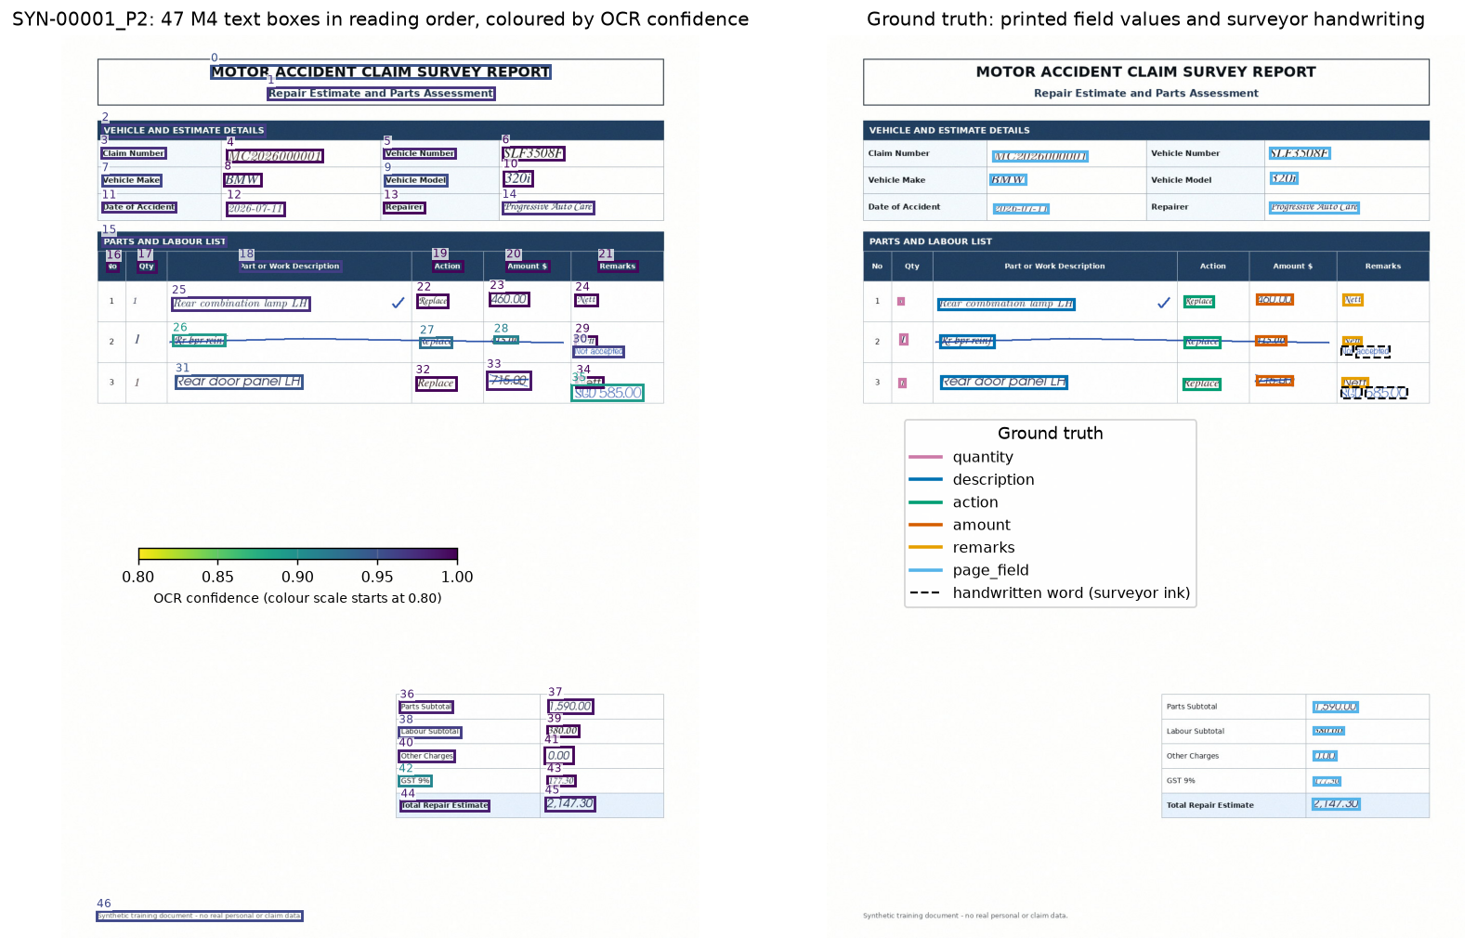
Figure 13. M4 output for a synthetic estimate page: OCR line boxes coloured by confidence (left) and the ground-truth fields and handwriting (right)
Table 17. M4 results on the 500-page synthetic dataset (M4 cache receipt, 12 October 2026)
Measure | Result
Pages processed | 500 (250 survey-assessment and 250 repair-estimate pages)
Text boxes returned | 29,402 line-level boxes
Page status | 497 complete, 3 unreadable
Unreadable pages | SYN-00093_P2 (train), SYN-00201_P2 and SYN-00213_P2 (validation): nested text boxes caused a granularity mismatch
Geometry correction | None needed on all 500 pages (flat synthetic scans, 1240 × 1754 px)
Runtime | claim-cmev-worker-ocr image, Linux ARM64, CPU

6.5 Limitations
M4 has been exercised on flat synthetic scans only, so its perspective and rotation corrections were never triggered on these pages. Word error rate and amount accuracy on real photographed estimates have not been measured. The synthetic pages also show that OCR confidence is not a reliable sign of obscured print: amounts under a pen stroke are sometimes misread with high confidence (Section 7.6). M4 therefore flags low-confidence text, leaves mark detection to M6 and leaves final decisions to the surveyor.

7.0 Module 5 (M5): Line-item Extraction (Arun)

7.1 Model
M5 fine-tunes Microsoft’s pretrained microsoft/layoutlmv3-base checkpoint for token classification (Huang et al., 2022; Microsoft, n.d.). LayoutLMv3 is a 12-layer transformer that reads three inputs together: the words, their two-dimensional positions on the page and patches of the page image (Figure 14). This lets it tell an amount in the Amount column from the same number in the subtotal block. The encoder starts from the pretrained weights, while a new classification head with 151 outputs starts from random values. The original specification proposed a rule-based parser; the live document deployment instead selects this neural model explicitly in configs/models/lineitems.yaml, and the parser remains available as a library (ACERY, 2026d).
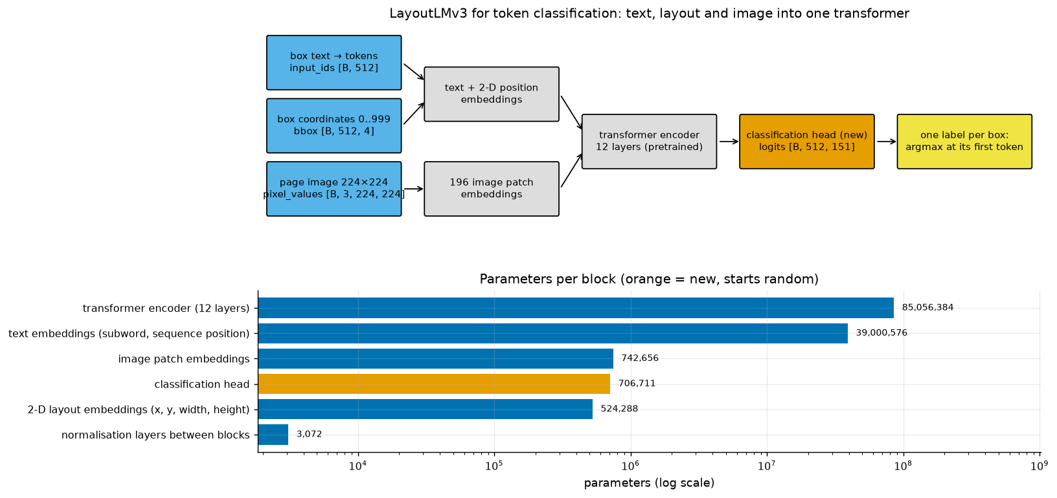
Figure 14. LayoutLMv3 token-classification model and its parameters per block

7.2 Training data
Both document models use synthetic_motor_claims_500_w_annotation, a team-generated dataset of 250 synthetic claims. Each claim has one survey-assessment page and one repair-estimate page, onto which the project rendered surveyor ink: exclusion crosses and strikes, revised prices, acceptance ticks and review notes. The split is inherited from the dataset and grouped by claim, so both pages of a claim always fall in the same partition (Table 18). All pages share one layout and three handwriting fonts. No CORD pre-training or real-estimate fine-tuning was performed, and the test partition was never evaluated (ACERY, 2026a).
Table 18. Synthetic document dataset and claim-grouped split used by M5 and M6
Partition | Claims | Assessment pages | Estimate pages | Total pages | Use
Train | 175 | 175 | 175 | 350 | Model fitting
Validation | 38 | 38 | 38 | 76 | Checkpoint and threshold selection; reported results
Test | 37 | 37 | 37 | 74 | Reserved; not evaluated
Total | 250 | 250 | 250 | 500

7.3 Aligning labels with OCR boxes
The dataset annotates field regions, but at serving time M5 receives M4’s OCR lines, which never match those regions exactly. Training labels are therefore transferred to the actual M4 boxes (Figure 15). A box takes a field’s label when at least half of the smaller of the two boxes overlaps. A box that overlaps no field becomes O (outside). A box that overlaps two fields, or printed text and handwriting at the same time, is masked and left out of the loss instead of being guessed. Each label combines a field type with a row slot (Table 19). The 75 field names, each with a begin (B-) and inside (I-) tag, plus O give 151 labels.
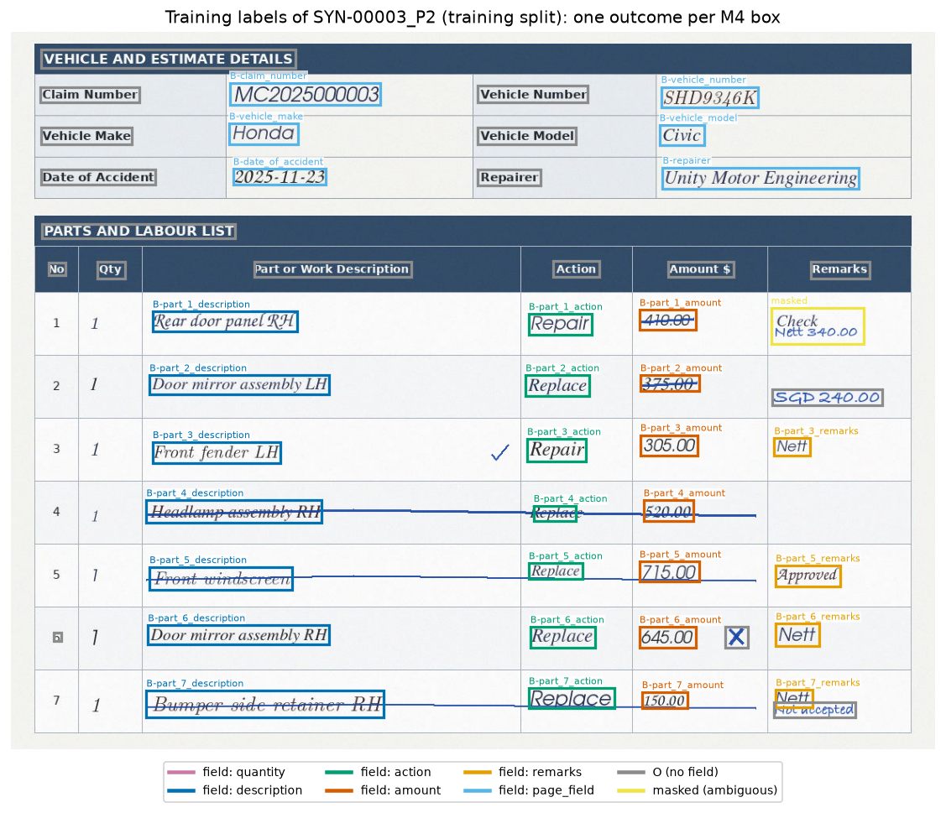
Figure 15. Training labels transferred to the M4 boxes of a training estimate page (SYN-00003_P2)
Table 19. M5 label scheme (m5-box-slot-labels/0.1.0)
Label group | Example labels | Meaning
Page fields | B-claim_number, B-vehicle_make, B-gst | Header and total fields on both page types
Row fields | B-part_3_description, B-part_3_action, B-part_3_quantity, B-part_3_amount, B-part_3_remarks | Field type plus row slot (part_1 to part_8) in the parts table
Outside | O | Printed text that belongs to no field, such as headings and column titles
Masked | none (not trained) | Box covering two fields, or print and ink together

7.4 Extraction workflow
Figure 16 shows how a page becomes line items. Each OCR line is split into subword tokens, box coordinates are scaled to a 0–999 grid and the page image is resized to 224 × 224 pixels. Pages longer than 512 tokens are split into windows that overlap by 64 tokens. The model predicts a label for every token, and each OCR box takes the label of its first subword. The serving adapter then groups boxes by row slot, maps part descriptions and operations to the project vocabulary and parses amounts as exact decimals. A missing quantity stays null instead of defaulting to one, low-confidence fields carry an uncertainty reason, and the declaration stays partial because complete-scope extraction has not been validated. Each line item keeps its row box and printed-amount box for M6.
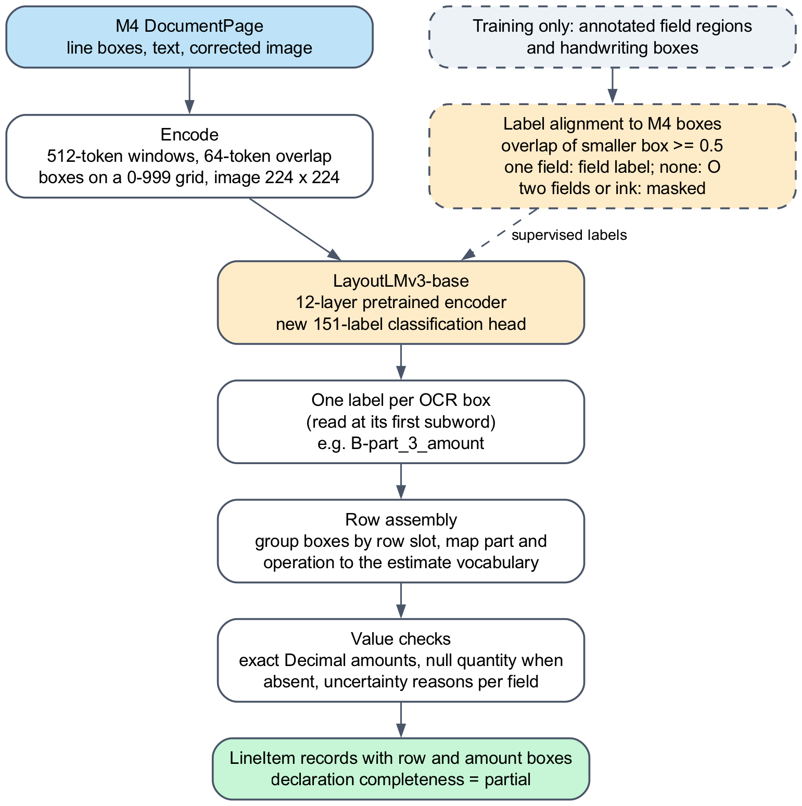
Figure 16. M5 line-item extraction workflow

7.5 Training
Table 20 lists the training settings. The checkpoint is chosen by validation entity F1, and training stops after five epochs without improvement. The selected run stopped after 13 epochs, kept epoch 8 (Figure 17) and took about 10.5 minutes on an Apple GPU (MPS). Its weights, labels, preprocessing and dependency versions are pinned in the model registry with SHA-256 hashes (ACERY, 2026b).
Table 20. M5 training configuration of the selected run
Setting | Value
Base checkpoint | microsoft/layoutlmv3-base (revision cfbbbff)
Optimiser | AdamW, learning rate 0.00005, weight decay 0.01
Schedule | 10% linear warm-up, then linear decay
Batch | 4 windows with 2 accumulation steps (effective 8); gradient clipping at 1.0
Epochs | At most 20; early stopping after 5 epochs without improvement
Selection | Validation entity F1; epoch 8 of 13 completed
Seed and hardware | 20260922; Apple Metal (MPS), 36 GB memory

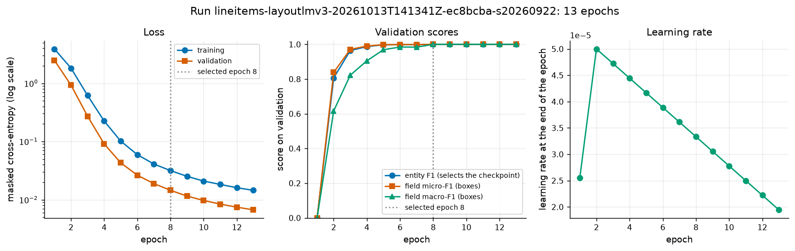
Figure 17. M5 training loss, validation scores and learning rate per epoch

7.6 Validation results
On the 76 validation pages the model labels all 4,324 scored OCR boxes correctly (Table 21). This score mostly reflects the fixed synthetic layout: a lookup that copies the label of the nearest training box from its coordinates alone, with no text, image or model, already labels 4,285 boxes correctly. The team’s earlier checkpoint, trained on annotation regions instead of M4 boxes, shows why aligning labels to real OCR output matters: it kept none of the outside boxes as O and completed only 21 of 206 rows.
Table 21. M5 box-level validation results compared with a coordinate-only lookup and the earlier checkpoint
Measure | This model (M4 boxes) | Coordinate-only lookup | Earlier checkpoint (annotation regions)
Scored boxes labelled correctly | 4,324 / 4,324 | 4,285 / 4,324 | not reported
Field boxes labelled correctly | 2,128 / 2,128 | 2,089 / 2,128 | 1,994 / 2,128
Field micro precision | 1.000 | 0.982 | 0.461
Outside boxes kept as O | 2,196 / 2,196 | 2,196 / 2,196 | 0 / 2,196
Entity F1 | 1.000 | not measured | 0.666
Rows complete (delivered fields) | 192 / 206 | not measured | 21 / 206

Box labels are not the final output. Table 22 scores the line items produced by the serving adapter against the 206 true rows. Rows on the two unreadable pages cannot be recovered. Amounts were exact for 129 of 138 rows without ink over the amount, but for only 48 of 68 rows where a surveyor mark crossed the printed amount, because OCR misreads such text. M4 found the quantity cell for only 28 rows, so most quantities stay null, and two misread quantities passed the format checks. Only 90 descriptions map to a part code, because the reviewed vocabulary does not yet cover many synthetic descriptions. Figure 18 shows the predicted labels on a validation page.
Table 22. Line items produced by the M5 serving adapter on validation (206 true rows)
Measure | Result
Line items produced | 192 of 206 true rows (14 rows on 2 unreadable pages; no extra rows)
Printed amount exact | 177 / 206 (clean amounts 129 / 138; amounts under ink 48 / 68)
Operation matched | 189 / 192
Part mapped to the vocabulary | 90 / 192
Quantity | 21 correct, 2 wrong but accepted, 169 null (quantity box delivered by M4 for 28 rows)
Description text similarity | Mean 0.990 over 192 rows
Declaration completeness | Partial for every claim, by design

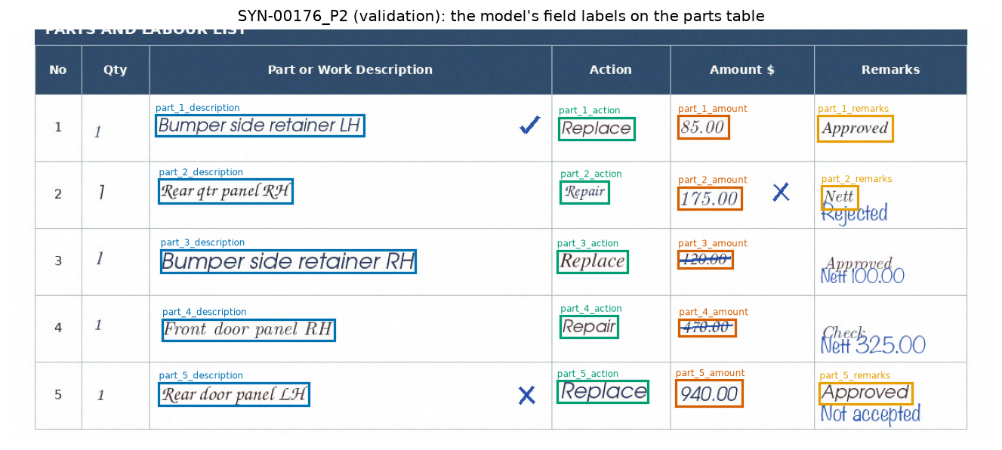
Figure 18. M5 field labels on the parts table of a validation estimate page (SYN-00176_P2)

7.7 Limitations
The model depends on absolute table position. In a stress test the field type stayed correct when the page content was moved, but the row slot did not: after a shift of one row height (79 pixels) the row slot was right for only 26 of 716 table cells when moved down and 184 of 716 when moved up (Figure 19). The candidate must therefore not be served on layouts that are not aligned with the training layout. M5 also cannot recover text or quantity boxes that OCR missed, and a misread number that is well formed passes the format checks. Real layouts, photographed pages and real handwriting remain unvalidated.
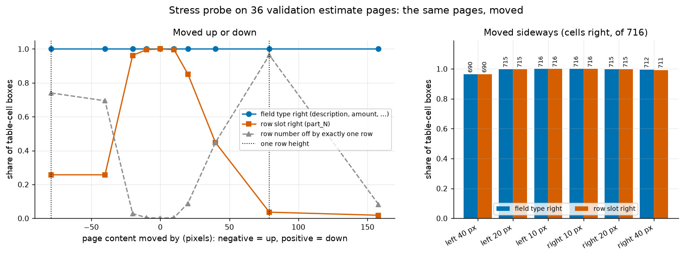
Figure 19. Position stress test on 36 validation estimate pages

8.0 Module 6 (M6): Pen-mark Recognition (Rodel)

8.1 Model
M6 fine-tunes torchvision’s Faster R-CNN detector with a ResNet-50 backbone and a feature pyramid network (FPN), initialised with the COCO_V1 weights (Ren et al., 2015; TorchVision maintainers, n.d.). Faster R-CNN works in two stages (Figure 20). A region proposal network suggests boxes that may contain an object, and a second head classifies each proposal and refines its box. The feature pyramid lets one model find both small crosses of about 20 × 23 pixels and row strikes more than 750 pixels wide. The pretrained backbone, pyramid, proposal network and box head are kept; only the final predictor is new, with three outputs: exclusion, price_change and background.
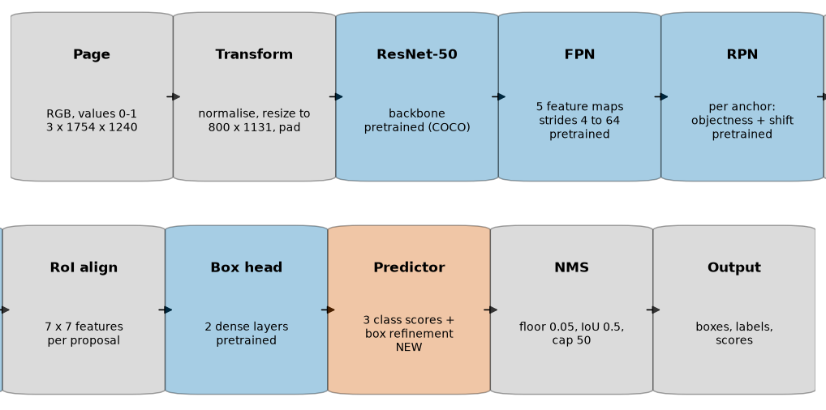
Figure 20. Faster R-CNN ResNet-50 FPN as used by M6, read left to right across both rows (blue: pretrained weights, orange: new layer, grey: no weights)

8.2 Training data and mark classes
M6 uses the same claim-grouped split as M5 (Table 18). COCO-format labels place one box around each logical mark, including any handwritten remark that belongs to it (Figure 21). Exclusions appear as a cross, a row strike, a remark, or a cross or strike with a remark. Price changes appear as a struck or crossed printed amount together with the revised amount. Acceptance ticks and review notes are on the pages but are not target classes, so the detector must learn to ignore them, and survey-assessment pages without target marks act as negative examples. All handwriting is rendered from fonts; no real team-marked estimates were used (ACERY, 2026a, 2026c).
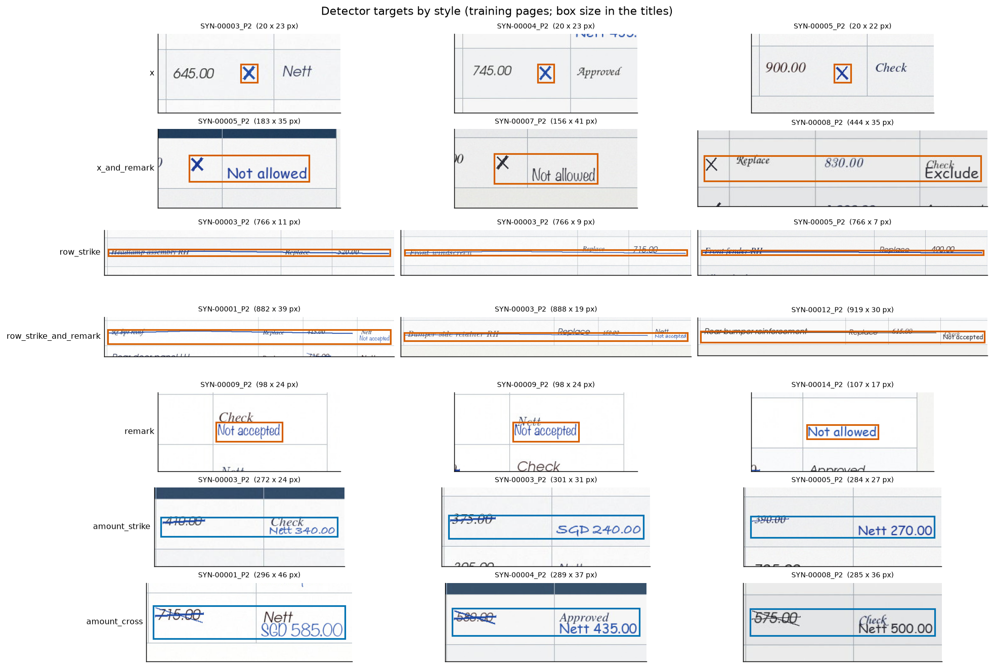
Figure 21. Training targets by mark style (orange: exclusion, blue: price change)

8.3 Training
Table 23 lists the training settings. Augmentation, applied to training pages only, varies brightness, contrast, blur, JPEG quality, shadows, scale and position, so that the model does not memorise pixel-perfect pages. The run completed all 20 epochs in about 35 minutes on an Apple GPU (MPS). The selection score, the mean over both classes of the best validation F1 at an IoU of 0.5, was highest at epoch 20 (Figure 22).
Table 23. M6 training configuration of the selected run
Setting | Value
Base weights | FasterRCNN_ResNet50_FPN_Weights.COCO_V1; 3 trainable backbone layers
New layers | Box predictor (class scores and box refinement) with 3 outputs
Input size | Short side 800 px, long side at most 1,333 px
Anchors | Sizes 32 to 512 px; aspect ratios 0.5, 1 and 2
Optimiser | SGD, learning rate 0.005, momentum 0.9, weight decay 0.0005
Schedule | 100-step warm-up; learning rate multiplied by 0.1 at 70% and 90% of training
Batch and epochs | Batch 4; 20 epochs; patience 5
Augmentation | Brightness and contrast ±12%, blur (p = 0.25), JPEG quality 45–90 (p = 0.35), shadow (p = 0.30), scale ±5%, shift ±20 px
Selection | Epoch 20; selection score 0.932

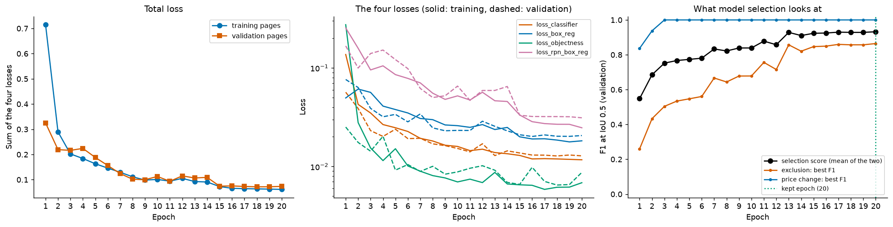
Figure 22. M6 training losses and validation selection score per epoch

8.4 Detection results and score thresholds
A detection counts as correct when it overlaps a labelled mark with an IoU of at least 0.5. Score thresholds were chosen per class on validation: the middle of the widest run of thresholds whose F1 is within 0.005 of the best (Figure 23). This gave 0.89 for exclusions and 0.59 for price changes. Because the same validation pages chose the epoch, the thresholds and the reported numbers, the results in Table 24 are optimistic.
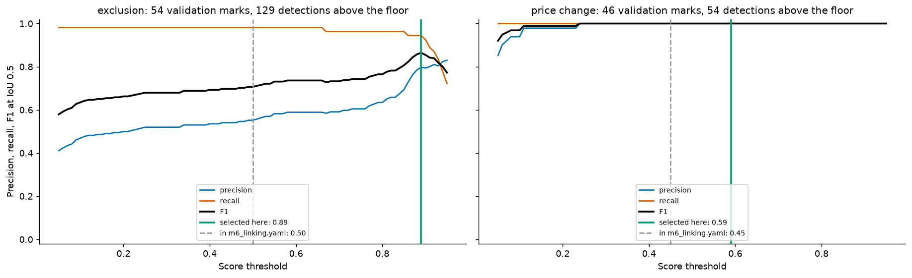
Figure 23. Precision, recall and F1 against the score threshold on validation
Table 24. M6 detection results on 76 validation pages at the selected operating point
Measure | Exclusion | Price change
Validation marks | 54 | 46
Average precision, IoU 0.5 | 0.847 | 1.000
Average precision, IoU 0.5–0.95 | 0.584 | 0.891
Score threshold | 0.89 | 0.59
Found / false positives / missed | 51 / 13 / 3 | 46 / 0 / 0
Precision | 0.797 | 1.000
Recall | 0.944 | 1.000
F1 | 0.864 | 1.000

Price changes were found without error. For exclusions, 11 of the 13 false positives are parts of a mark that was also found as a whole, such as the cross of a cross-and-remark mark; the other two are poorly placed boxes. None fell on the 43 pages without marks or on ticks and notes. Recall was lowest for remark-only exclusions (Table 25). Lowering the exclusion threshold to 0.50 would find 53 of 54 exclusions but raise false positives to 43; this trade-off between missed marks and extra proposals for the surveyor remains a team decision.
Table 25. M6 detection recall by mark style at the selected thresholds
Class | Mark style | Found / marks
Exclusion | Cross | 12 / 12
Exclusion | Cross and remark | 13 / 13
Exclusion | Row strike | 11 / 12
Exclusion | Row strike and remark | 11 / 11
Exclusion | Remark only | 4 / 6
Price change | Printed amount struck through | 24 / 24
Price change | Printed amount crossed | 22 / 22

8.5 Linking marks to repair rows
A detection alone does not say which repair row the surveyor meant. M6 links each mark to an M5 row with deterministic rules (Figure 24). Each row box is extended into a band, 0.6 row heights above and 0.25 below, because revised prices are usually written above the printed amount. For every mark and row the linker computes the vertical overlap (v), mark containment (c), row coverage (rc) and whether the mark lies in an allowed column (col), and combines them into a link score. An exclusion is linked only when one row scores at least 0.50 and leads the next row by at least 0.20 (rule EX-1). A price change is linked when it uniquely overlaps one printed amount (PC-1) or leads by the stricter margin of 0.35 (PC-2). Otherwise the mark stays unlinked and keeps its candidate rows for the surveyor (PC-3).
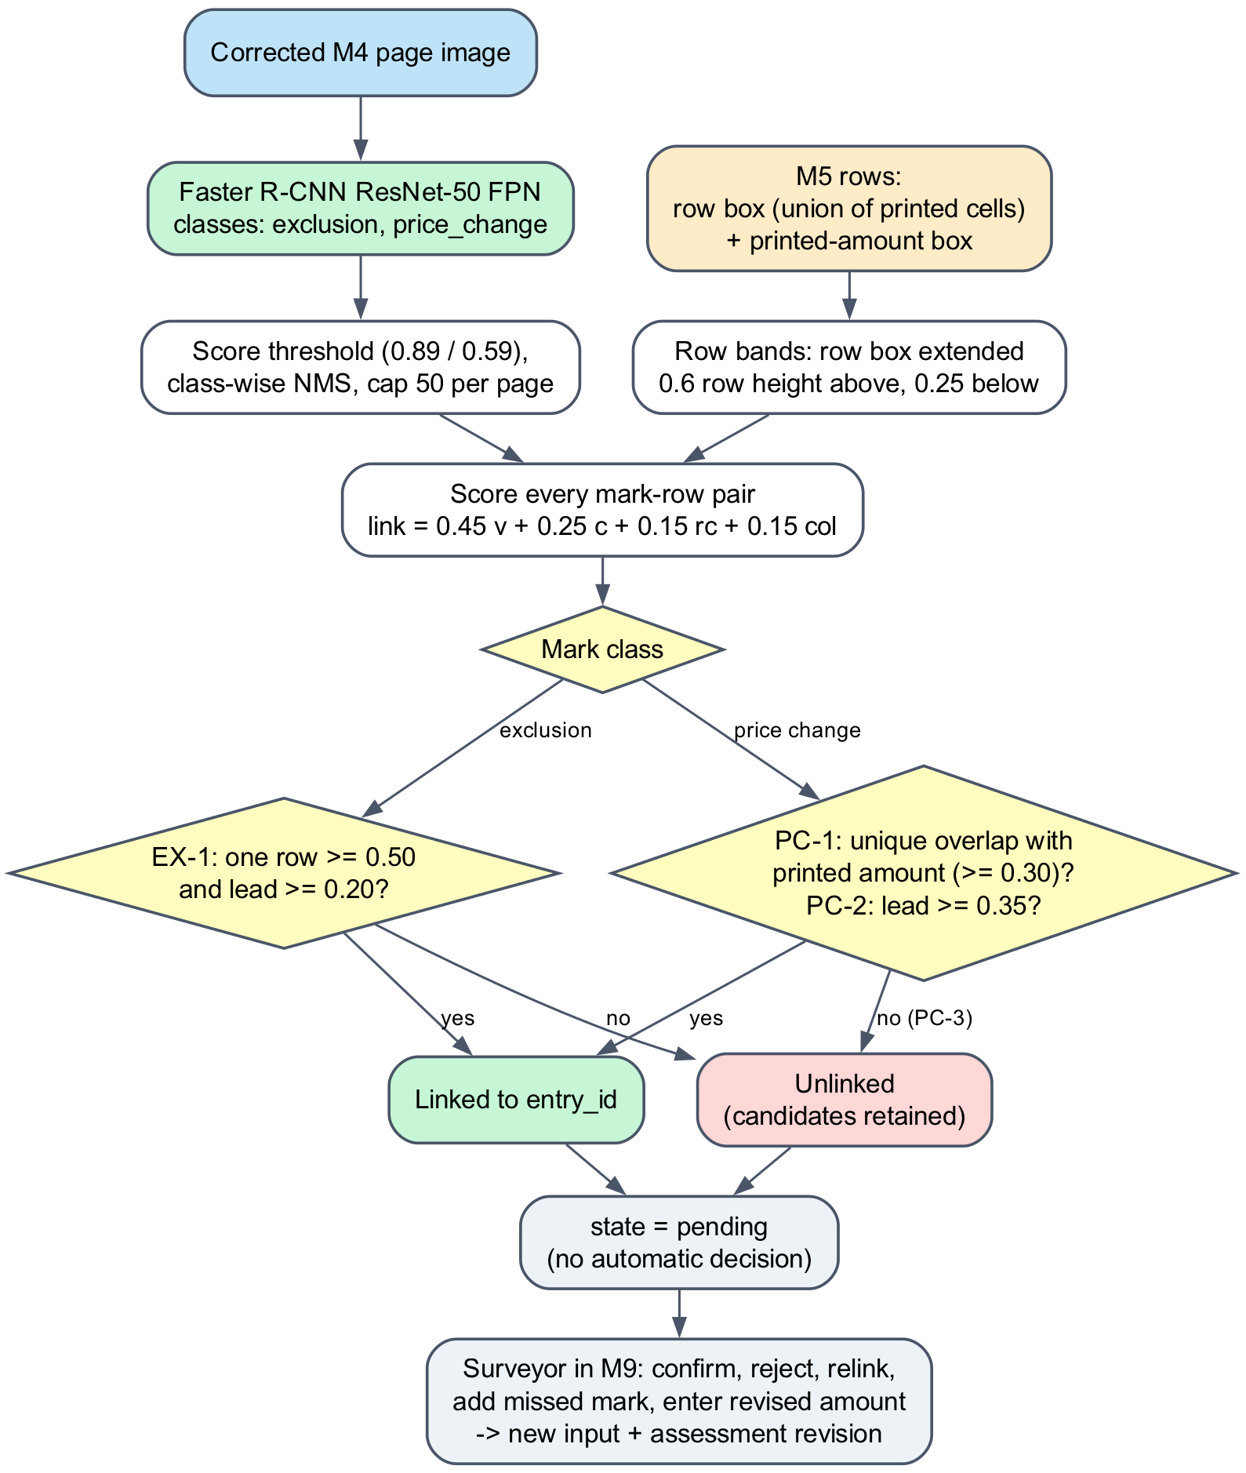
Figure 24. M6 detection and deterministic row-linking workflow
Linking depends strongly on the row boxes it receives (Table 26). With ideal rows built from the union of each row’s printed cells, 47 of 54 excluded rows and all 46 repriced rows were flagged. With the rows actually produced by M5, exclusion recall fell to 32 of 54: fourteen rows were missing on unreadable pages, and some M5 row boxes are larger than the printed cells, which leaves more marks between rows. The full table-row band is shown only as a contrast, because M5 does not supply such rows. In every setting no mark was linked to the wrong row; uncertain marks stayed unlinked instead. Figure 25 shows linked and unlinked marks on validation pages.
Table 26. M6 row-level linking on validation with the selected detector and the unchanged linker configuration
Rows given to the linker | Excluded rows flagged | Repriced rows flagged | Marks linked / unlinked | Row precision
Printed-cell union (ideal rows) | 47 / 54 | 46 / 46 | 101 / 9 | 1.000
Rows produced by M5 (actual chain) | 32 / 54 | 43 / 46 | 79 / 31 | 1.000
Full table-row band (contrast only) | 12 / 54 | 46 / 46 | 61 / 49 | 1.000

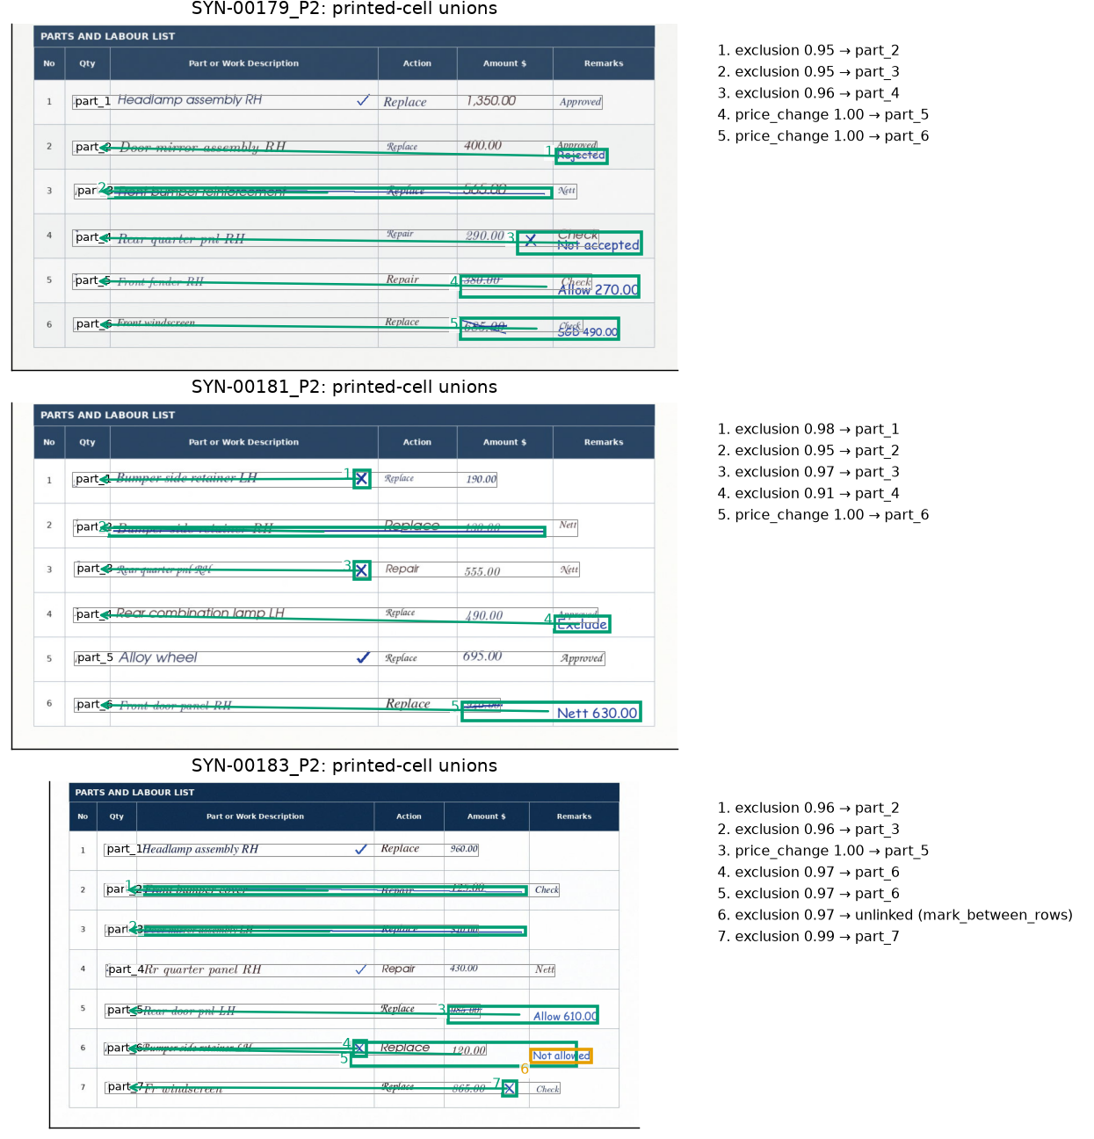
Figure 25. Proposed marks and row links on three validation pages; every mark starts as pending

8.6 Human review and revisions
M6 proposes and never decides. Every mark starts as pending, and only the surveyor’s actions in M9 change its state (Table 27). A pending exclusion withholds the row’s checks instead of removing the row, and a pending price change never falls back to the printed amount. TrOCR amount reading is disabled, so a revised price always comes from an amount the surveyor types, with its currency and cost basis. Each decision-changing action creates a new input and assessment revision, while the original detections, the action history and earlier assessments are kept.
Table 27. Surveyor actions on M6 proposals; each decision-changing action creates a new input and assessment revision
Surveyor action | Mark state | Effect on the M8 checks
None yet | pending | Exclusion: row withheld. Price change: price unresolved, never the printed amount
Confirm exclusion | confirmed | Row is excluded from the checks
Confirm price change | confirmed, with exact amount, currency and cost basis | Surveyor amount becomes the effective price
Reject mark | rejected (kept and shown as dismissed) | Row keeps its printed amount
Correct link | linked to the chosen row (model link kept) | Checks apply to the chosen row
Add missed mark | confirmed, origin human_added | As for a confirmed mark
Enter amount | amount replaced (history kept) | New effective price

8.7 Integration and limitations
The live document deployment runs M4, M5 and M6 as separate containers chained through Kafka. Each worker verifies its pinned model files at start-up and refuses to start with missing or mismatched weights. On the live stack, two synthetic training pages passed through upload, M4, M5, M6 and M8, producing three line items and two pending marks; confirming a price change created a new revision that reused the stored M4 to M6 results (ACERY, 2026d).
All results are synthetic validation evidence on one layout with font-rendered ink. They do not establish performance on real marks, unseen layouts or unseen writers. The specification’s acceptance targets, precision and recall of at least 0.90 for exclusions and 0.85 for price changes on held-out team-marked pages, remain unevaluated.

9.0 M7 (Edwin)

10. M8 (Edwin)

11. Integration of all modules (Rodel)

11.1 How the modules connect
This section explains how the nine modules described in Section 2 work together. The modules never call each other: each one reads the stored results of the modules before it and writes its own, and the orchestrator decides when the next stage may start. Figure 26 shows what each module hands to the next.
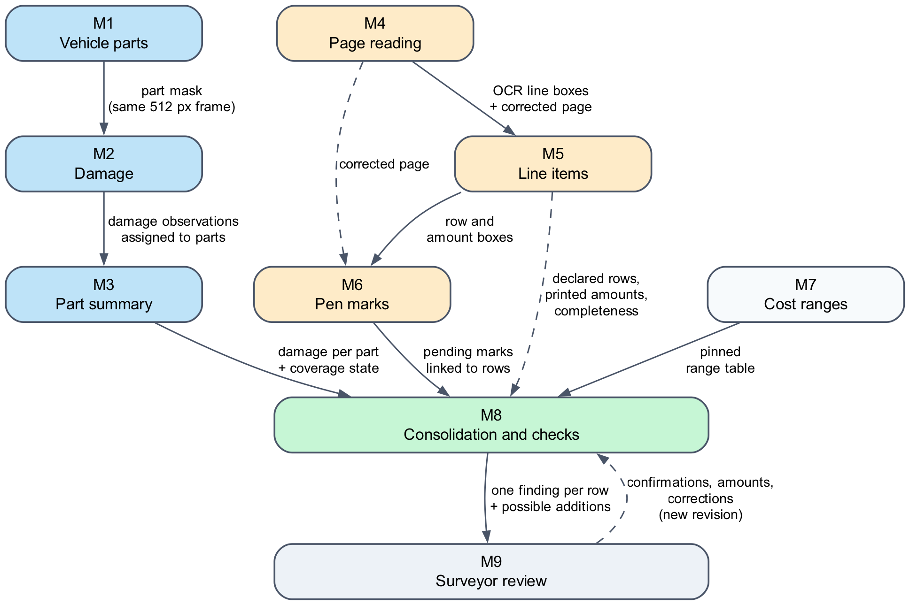
Figure 26. Data handed between modules

11.2 Integration within each branch
In the photograph branch, M1 and M2 process every photograph in the same 512-pixel image frame, so each damage region can be compared pixel by pixel with the part mask. M2 assigns a region to a part only when the overlap is clear; otherwise the region stays unassigned and keeps its candidate parts. M3 then groups the observations by part and judges photo coverage, which also needs the surveyor to confirm the part and side each photograph shows.
In the document branch, M4 produces one corrected page image that both M5 and M6 use, so their coordinates match. M5 turns the OCR lines into repair rows and keeps each row’s box and printed-amount box. M6 links every pen mark to a row using exactly these stored boxes.

11.3 Joining the two branches
The two branches meet only in M8. For each declared row, M8 finds the photographic summary for the same part, works out the effective price from the printed amount and any confirmed pen mark, and looks up the M7 range for that part, operation and vehicle class. The join is made for one input revision at a time, and every input carries its versions, so results from different revisions are never mixed. A missing or failed input gives “more information needed”, never a pass.

11.4 The human feedback loop
Integration does not end with M8. When the surveyor confirms a mark, enters an amount or confirms a part in M9, the action is recorded and a new input revision is created. The orchestrator reruns only the stages whose inputs changed. A confirmed price change, for example, reuses the stored M4, M5 and M6 results and reruns only M8, so no model runs again; a confirmed part identity reruns M3 and M8. The old assessment stays available for audit.

11.5 End-to-end checks
The integrated system was run with all real models in Docker on a local workstation. In one check, two claims, with six photographs and four estimate pages between them, each completed all 13 stage jobs (26 in total), producing 216 OCR boxes, six extracted rows and four pending pen marks. Separate checks showed that confirming a price change reuses the stored document results, and that a repeated Kafka delivery creates no duplicate records. These checks show that the modules work together; they do not measure accuracy on real claims, because the inputs were public-dataset photographs and synthetic estimates.

12.0 Overall discussion (everyone)
The integration of vehicle part and damage segmentation provides an initial framework for transforming photographic evidence into structured information describing the location and nature of vehicle damage. Such information could support more systematic documentation and comparison of vehicle damage across insurance claims. When combined with historical repair and replacement cost data, the structured outputs could potentially facilitate cost benchmarking and the identification of discrepancies between observed damage and proposed repair costs. However, the present integration experiments evaluated damage-to-part association rather than repair cost prediction or fraud detection. Therefore, these applications should be regarded as potential future developments rather than demonstrated outcomes of the current study.

13.0 Limitations (everyone)
Several limitations should be considered when interpreting the integration findings. First, the evaluation was conducted using 132 held-out images from the HITL dataset. Although leakage-controlled splitting procedures were applied, the findings may not generalise to other photographic conditions, vehicle types, or real-world insurance claims datasets.
Second, the assignment rate was calculated based on detected damage regions rather than ground-truth damage-to-part associations. Consequently, a high assignment rate does not necessarily indicate that damage regions were correctly assigned to vehicle parts.
Third, the integration relied on the accuracy of independently trained segmentation models. Errors in either module could propagate through the containment calculations and affect assignment outcomes.
Fourth, the deterministic approach primarily assigns each damage component to a single vehicle part. This may not fully represent genuine damage spanning multiple vehicle components.
Finally, although seam-guided splitting improved automated assignment rates, the resulting fragments were not independently validated to determine whether they represented genuine damage to adjacent vehicle parts.
Future work should therefore focus on evaluating assignment accuracy against expert-annotated ground truth, examining the effects of segmentation errors on downstream performance, and validating seam-guided splitting policies before deployment.

14.0 Conclusion

15.0 References
Ahaggach, H., Abrouk, L. and Lebon, E. (2024) ‘Enhancing car damage repair cost prediction: Integrating ontology reasoning with regression models’, Intelligent Systems with Applications, 23, p. 200411. Available at: https://doi.org/https://doi.org/10.1016/j.iswa.2024.200411.
Dalal, S. et al. (2026) ‘Harris Hawks–tuned severity-aware YOLOv8 instance segmentation framework for vehicle damage assessment’, Scientific Reports, 16(1), p. 20183. Available at: https://doi.org/10.1038/s41598-026-50925-0.
Dimri, A. et al. (2022) ‘A multi-input multi-label claims channeling system using insurance-based language models’, Expert Systems with Applications, 202, p. 117166. Available at: https://doi.org/https://doi.org/10.1016/j.eswa.2022.117166.
General Insurance Association, S. (2026) Singapore’s Domestic General Insurance Business Surpasses S$6 billion in Premiums Amid 11% Rise in Motor Claims. Available at: https://mail.gia.org.sg/agents/media-center/company-news/592-gi-results-2025.html?utm_source=chatgpt.com (Accessed: 11 October 2026).
Levich, S., Lutz, B. and Neumann, D. (2023) ‘Utilizing the omnipresent: Incorporating digital documents into predictive process monitoring using deep neural networks’, Decision Support Systems, 175, p. 114043. Available at: https://doi.org/https://doi.org/10.1016/j.dss.2023.114043.
MSIG (2016) Road is their Stage, Fraud is their Game. Available at: https://www.msig.com.sg/blogs/road-their-stage-fraud-their-game (Accessed: 11 October 2026).
Pérez-Zarate, S.A. et al. (2024) ‘Automated Car Damage Assessment Using Computer Vision: Insurance Company Use Case’, Applied Sciences, p. 9560. Available at: https://doi.org/10.3390/app14209560.
van Ruitenbeek, R.E. and Bhulai, S. (2022) ‘Convolutional Neural Networks for vehicle damage detection’, Machine Learning with Applications, 9, p. 100332. Available at: https://doi.org/https://doi.org/10.1016/j.mlwa.2022.100332.
Schrijver, G., Sarmah, D.K. and El-hajj, M. (2024) ‘Automobile insurance fraud detection using data mining: A systematic literature review’, Intelligent Systems with Applications, 21, p. 200340. Available at: https://doi.org/https://doi.org/10.1016/j.iswa.2024.200340.

Additional references for M4–M6
ACERY (2026a) Synthetic surveyor annotation dataset and M4 cache receipt. Project repository: docs/synthetic-surveyor-annotations.md; data/manifests/synthetic_motor_claims_m4_cache_20261012.json.
ACERY (2026b) M5 Document Worker: OCR alignment, LayoutLMv3 training and serving checks. Project notebook: notebooks/M5_Document_Worker.ipynb.
ACERY (2026c) M6 Document Worker: pen-mark detection, training and row-linking evaluation. Project notebook: notebooks/M6_Document_Worker.ipynb.
ACERY (2026d) M4–M6 specifications and live document worker implementation. Project repository: M4 specification; M5 specification; M6 specification; live worker operations.
Huang, Y., Lv, T., Cui, L., Lu, Y. and Wei, F. (2022) ‘LayoutLMv3: Pre-training for Document AI with Unified Text and Image Masking’. Available at: https://arxiv.org/abs/2204.08387. (Accessed: 24 October 2026).
Microsoft (n.d.) microsoft/layoutlmv3-base: model card and pretrained checkpoint. Available at: https://huggingface.co/microsoft/layoutlmv3-base. (Accessed: 24 October 2026).
PaddleOCR contributors (n.d.) PaddleOCR v2.10 model list: English detection, recognition and orientation models. Available at: https://www.paddleocr.ai/v2.10.0/en/ppocr/model_list.html. (Accessed: 24 October 2026).
Ren, S., He, K., Girshick, R. and Sun, J. (2015) ‘Faster R-CNN: Towards Real-Time Object Detection with Region Proposal Networks’. Available at: https://arxiv.org/abs/1506.01497. (Accessed: 24 October 2026).
TorchVision maintainers (n.d.) fasterrcnn_resnet50_fpn: model documentation and COCO_V1 weights. Available at: https://docs.pytorch.org/vision/stable/models/generated/torchvision.models.detection.fasterrcnn_resnet50_fpn.html. (Accessed: 24 October 2026).

Appendices

Appendix A: Project Proposal
[Placeholder: insert the CLAIM-CMEV project proposal here.]

Appendix B: Deployment Guide
This guide starts the complete system on one computer with Docker. The source code is at https://github.com/RodelFMiguel/CLAIM-CMEV. More detail is in the repository’s README.md and infra/README.md.
Table B.1. Requirements
Item | Requirement
Software | Docker Desktop or Docker Engine with Compose v2, and Git
Hardware | CPU only; no GPU is needed
Model files | The exported model folders in Table B.2. Trained weights are not stored in Git; obtain them from the project team
Network | Internet access for the first build and the OCR weight download

1. Get the code. Clone the repository and open its folder:
git clone https://github.com/RodelFMiguel/CLAIM-CMEV.git
cd CLAIM-CMEV
2. Configure. Copy the example settings and replace the placeholder passwords (CMEV_DB_PASSWORD, CMEV_OBJECT_STORE_ACCESS_KEY, CMEV_OBJECT_STORE_SECRET_KEY and CMEV_DEMO_PASSWORD). CMEV_WEB_PORT sets the browser port; the default is 8080.
cp infra/compose/.env.example infra/compose/.env
3. Add the model files. Copy each model folder into artifacts/models/ so that its path matches Table B.2, then download the pinned OCR weights. The M7 cost table needs no files: it is built automatically when the stack starts.
python3 scripts/download_ocr_models.py
Table B.2. Model folders expected under artifacts/models/
Module | Folder
M1 | parts/parts-segformer-20261009T165726Z-ab6d41d2-serving
M2 | damage-cardd/damage_cardd-segformer-20261018T160256Z-377ddc4e-serving
M4 | ocr/paddleocr-2.10.0-en-v1 (created by the download script)
M5 | lineitems/lineitems-layoutlmv3-20261013T141341Z-ec8bcba-s20260922-serving
M6 | penmarks/penmarks-fasterrcnn-20261013T142838Z-78d92779-serving

4. Start the system. Build and start all services. The first build takes several minutes.
sh scripts/live-stack.sh up --build -d
5. Check and sign in. Wait until every service shows healthy, then open http://localhost:8080 and sign in as surveyor@claim-cmev.demo with the CMEV_DEMO_PASSWORD you set.
sh scripts/live-stack.sh ps
6. Stop. Stop all services. Stored claims are kept in Docker volumes for the next start.
sh scripts/live-stack.sh down
Troubleshooting. A model worker that stops right after start-up usually has a missing or mismatched model folder; its log names the problem. To demonstrate the interface without model files, stop the live stack and start the base Compose file alone, which uses demonstration fixtures.
sh scripts/live-stack.sh logs --tail 50 cmev-worker-image
docker compose --env-file infra/compose/.env -f infra/compose/docker-compose.yml --profile lean up --build -d

Appendix C: User Guide
This guide follows the main workflow of a desk surveyor reviewing one claim. Model results are proposals; every decision is made by the surveyor.
C.1 Open the claim queue. Sign in at http://localhost:8080. The queue lists each claim with its status, the declared estimate and the agreed amount. Select a claim to open it, or select New claim.
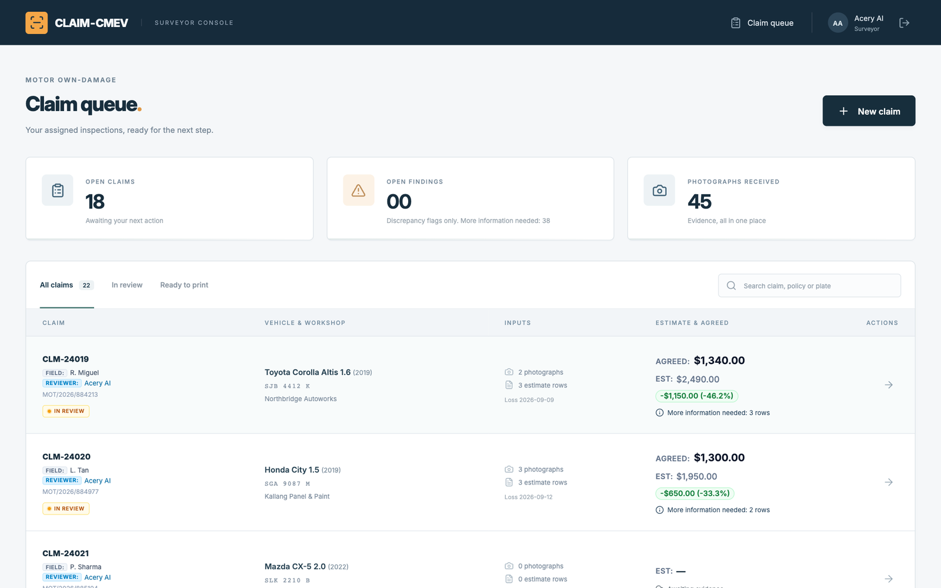
Figure C.1. Claim queue
C.2 Create a claim. Enter the claim and vehicle details, add the damage photographs and the marked estimate (JPEG, PNG or PDF), then select Upload & start review. The models run in the background, and the review opens when the first assessment is ready.
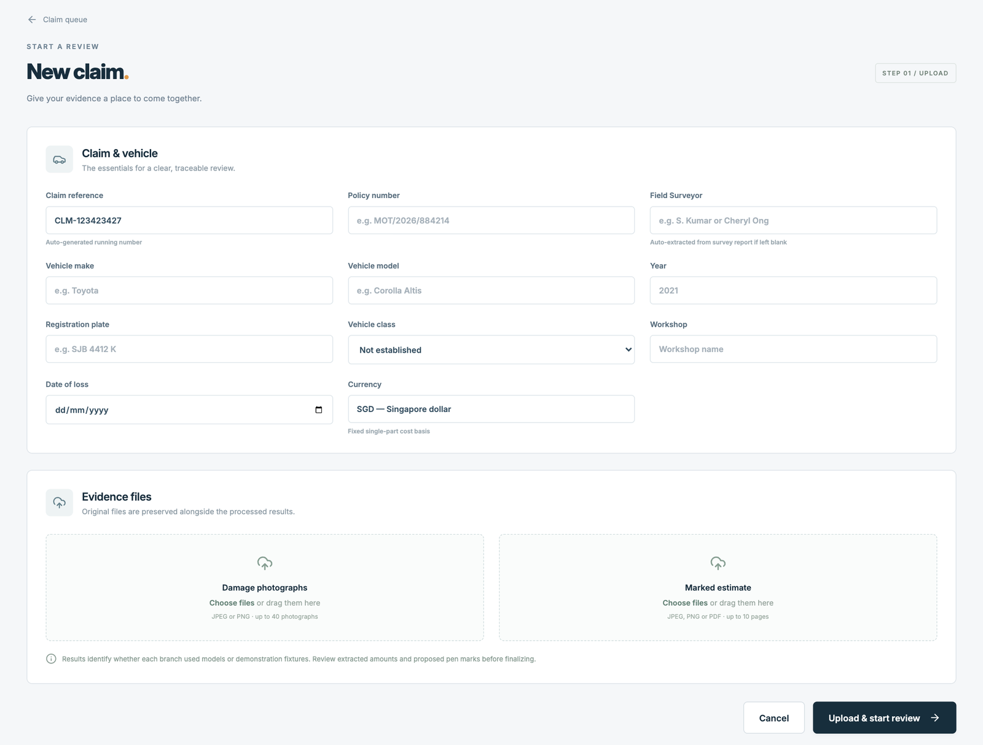
Figure C.2. New claim form with evidence upload
C.3 Read the review overview. The damage summary on the left lists the damage found for each vehicle part and whether its photo coverage still needs confirmation. The evidence panel on the right keeps the original photographs and estimate pages.
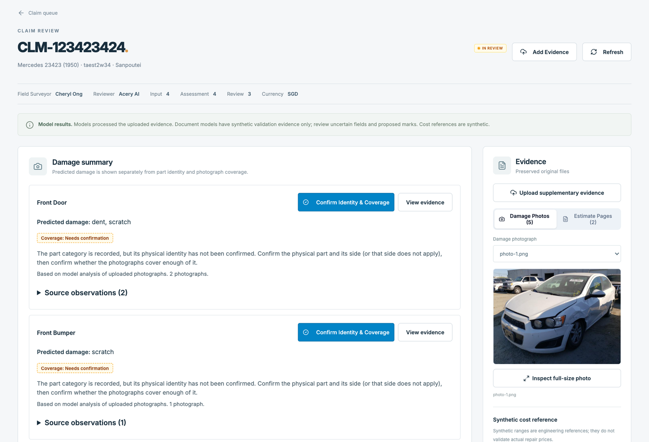
Figure C.3. Review overview with the damage summary and evidence panel
C.4 Check the photographs. Select View evidence to see the photographs with the predicted damage regions. Use the defect filter to show one damage type, or clear Show defect overlay to see the original photograph.
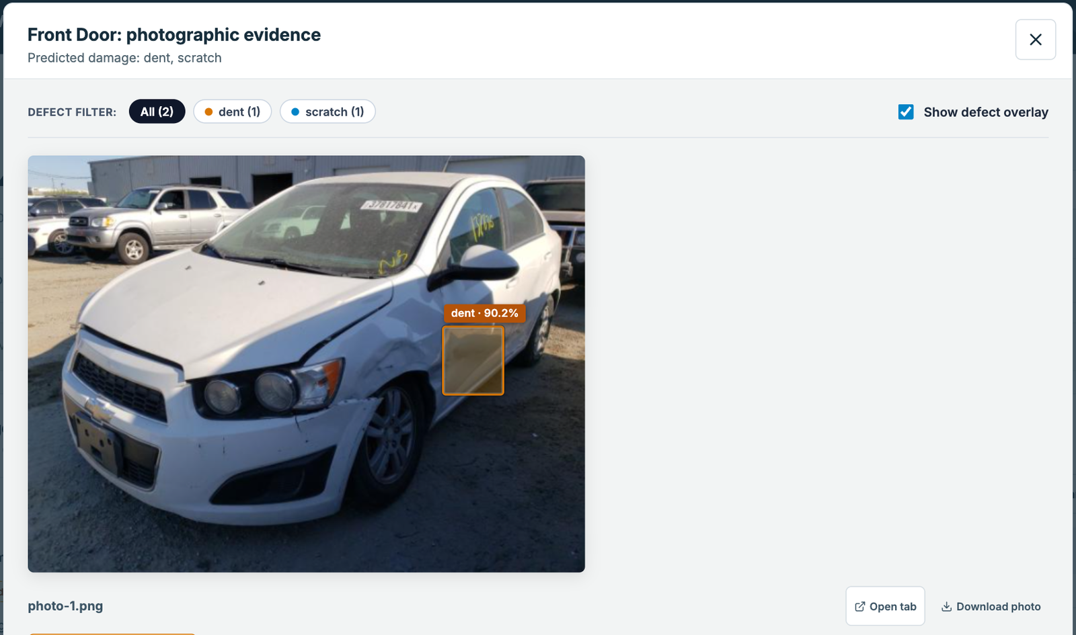
Figure C.4. Photographic evidence with predicted damage regions
C.5 Confirm part identity and coverage. Select Confirm Identity & Coverage. Choose the vehicle part and side, tick the photographs that show it and state whether they cover the part adequately. Nothing is pre-filled: each choice is the surveyor’s.
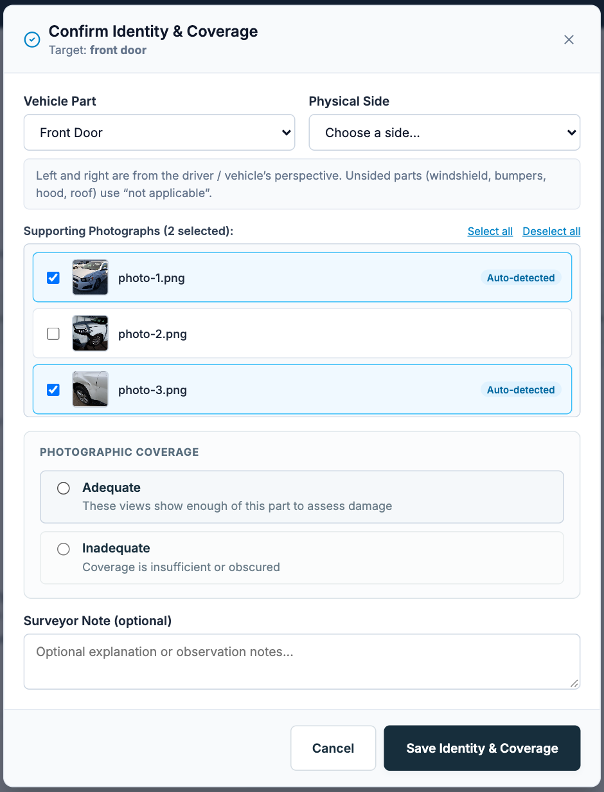
Figure C.5. Identity and coverage confirmation
C.6 Decide each pen mark. Under Estimate line items, every proposed pen mark starts as pending, and a pending price change is never priced at the printed amount. For a price change, type the revised amount and select Confirm price change, or select Reject mark; an exclusion is confirmed or rejected in the same way. Use Correct Row or Add Missed Mark when the extraction is wrong or a mark was missed. Each decision creates a new revision.
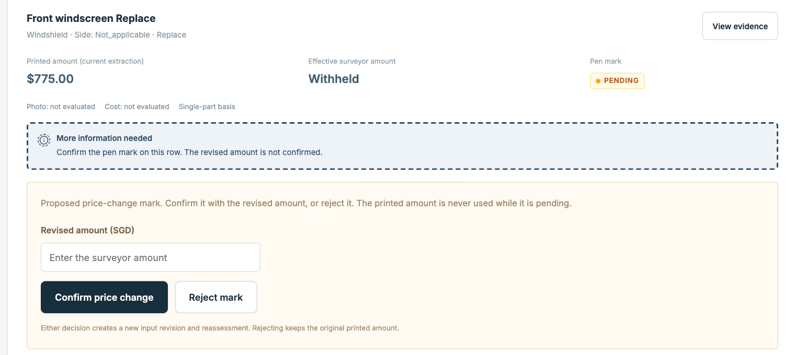
Figure C.6. Pending price-change mark on an estimate row
C.7 Finalise the review. At the end of the estimate, select Confirm Completeness once all pages and rows are present. The Ready to finalize? panel lists anything still blocking, such as pending marks; when it is empty, select Finalize review.
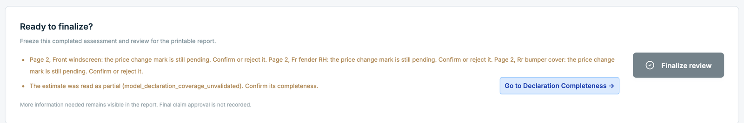
Figure C.7. Finalisation panel listing the remaining blockers
C.8 Print the report. Select Print report on the review page or in the claim queue, then Print to PDF. The frozen report lists each estimate line, the surveyor’s decisions and the model versions used. Final claim approval is not recorded by the system.
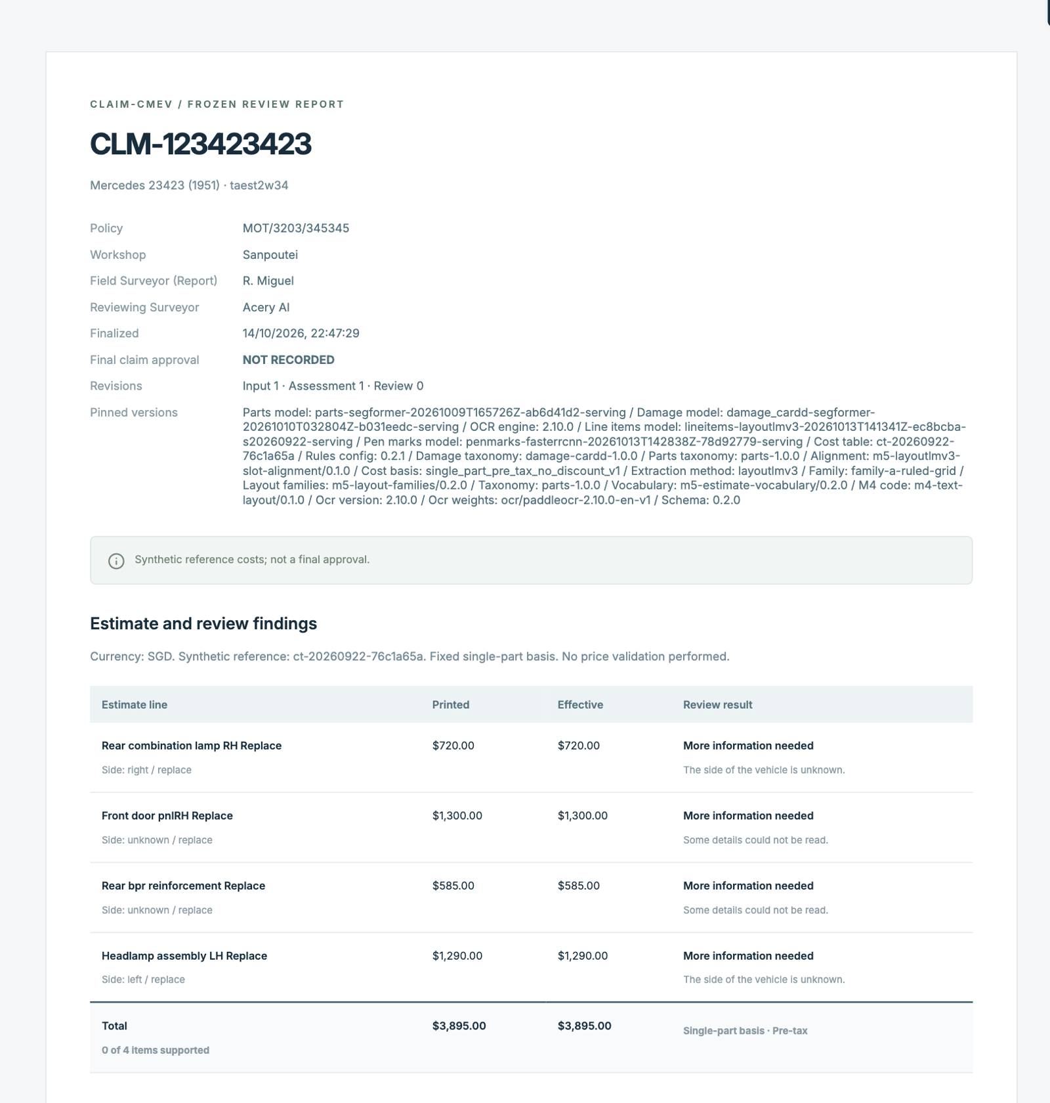
Figure C.8. Frozen review report

